**Abstract**

The suggested voting system provides an entire system for staging elections online while stressing accessibility, security, and efficiency. The program has a variety of functionalities that cover the full electoral process, including election setup, voter registration, ballot casting, and results generation. Administrators can easily oversee elections, add users, and track system performance. Meanwhile, voters may securely engage using a simple interface. The system includes authentication and authorization systems to enable secure access and safeguard sensitive data. User profiles allow for more tailored interactions, whilst dashboards give an overview of key information and metrics. In essence, this voting system provides a dependable, user-friendly platform for holding fair and transparent elections in a variety of settings.

Table of Contents

**Voting System** 8

**Chapter 1: Introduction** 8

**1.2** **Current Scenario** 8

**1.3** **Problem Domain and project as solution** 8

**1.4** **Aim and objectives** 9

**1.5** **Structure of the report** 10

**2.** **Background** 10

**2.1** **About the end users** 10

**2.1.1** **User** 10

**2.2** **Understanding the solution** 10

**2.2.1** **Project Elaboration** 10

**2.2.2** **System Architecture** 10

**2.2.3** **Terms and definition** 10

**2.2.4** **Functions and features** 11

**2.3** **Similar projects** 11

**2.4** **Comparison** 13

**Chapter 3: Development** 14

**3.** **Development** 14

**3.1** **Considered methodologies** 14

**3.1.4** **Comparison between them** 15

**3.2** **Selected Methodology** 16

**3.3** **Phases of methodology** 16

**3.4** **Survey results** 19

**3.4.1** **Pre-survey results** 19

**3.4.2** **Post- survey results** 22

**3.5** **Requirement Analysis** 25

**3.6** **Design** 25

**3.6.1** **Gantt Chart** 26

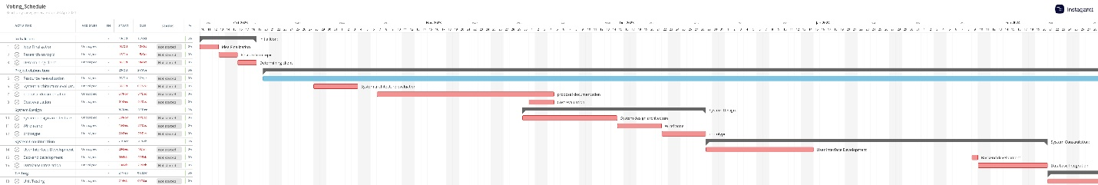 26

https://app.instagantt.com/shared/6628286d41670d12d33c1ece 26

**3.6.2** **Logo** 26

**3.6.3** **Use Case diagram** 26

**3.6.4** **Algorithm** 27

**3.6.5** **Flow Chart** 27

**3.6.6** **Dataflow Diagram** 28

**3.6.7** **System Activity diagram** 28

**3.6.8** **Class diagram** 29

**3.7** **Graphical User Interface** 29

**3.7.1** **Wire Frames** 29

**3.7.2** **Application Design** 31

**3.8** **Implementation** 34

**3.8.1** **Database design** 34

**3.8.2** **Code Implementation** 34

**Chapter 4: Testing and Analysis** 37

**4.** **Testing and analysis** 37

**4.1** **Test Plan** 37

**4.3** **System Testing** 46

**4.4** **Critical Analysis** 52

**Chapter 5: Conclusion** 53

**5.** **Conclusion** 53

**5.1** **Legal Issues, Social Issues, Ethical issues** 54

**5.1.1** **Social Issues** 54

**5.1.2** **Legal Issues** 54

**5.1.3** **Ethical Issues** 54

**5.2** **Advantages** 54

**5.3** **Future work** 55

**5.4** **Limitation** Despite of other thing, there are several limitations which includes 55

**Chapter 6: Reference and Biography** 56

**6.** **References and bibliography** 56

List of Figures

Figure 1- admin panel 14

Figure 2 - Registration of Indian Election 15

Figure 3-Indian Election 16

Figure 4 - Scrum methodology 16

Figure 5 - Iterative model 17

Figure 6 – Kanban 17

Figure 7 - DSDM 19

Figure 8 - Gantt Chart 29

Figure 9 - LOGO 30

Figure 10 - Use case diagram 30

Figure 11 - Flow chart 31

Figure 12 - Dataflow Diagram 31

Figure 13 - System Activity Diagram 32

Figure 14 - Class Diagram 33

Figure 15- Wireframe of Dashboard 34

Figure 16 -Wireframe of Sign In 34

Figure 17 - Application design of Sign up page 36

Figure 18 - Application design of sign in page 36

Figure 19 - Application design of dashboard 37

Figure 20 - Application design of elections 37

Figure 21 - Application design of candidates 38

Figure 22 - Models to start the election (1) 39

Figure 23 - Models to start the election (2) 40

Figure 24 - To create the model for the user 41

Figure 25 - Unit test(1) 42

Figure 26 - Unit Test(2) 43

Figure 27 - Unit Test(3) 44

Figure 28- Unit Test (4) 44

Figure 29 - Unit Test (5) 45

Figure 30 - Unit Test(6) 45

Figure 31 - Unit Test(7) 46

Figure 32 - Unit Test (8) 46

Figure 33 - Unit Test (9) 47

Figure 34 - Unit Test (10) 47

Figure 35 - Unit Test (11) 48

Figure 36 - Unit Test (12) 48

Figure 37 - Unit Test (13) 49

Figure 38 - Unit Test (14) 49

Figure 39 - Unit Test (15) 50

Figure 40 - System Testing (1) - Account is created 50

Figure 41 - System Testing (2) -Login is successful 51

Figure 42 - System Testing (3) -User can login 51

Figure 43 - System Testing (4) -Creating election 52

Figure 44 - System Testing (5) -Successfully created election Figure 45 - System Testing (6) - voting the candidate 52

Figure 46 - System Testing (7) -Successfully voted in the election 53

Figure 47 - System Testing (8) -Results can be displayed like this 53

Figure 48 - System Testing (9) -Adding, editing and deleting election 54

Figure 49 - System Testing (10) -Admin who have control about editing, deleting the canidates 54

Figure 50 - System Testing (11) -Admin can declare winner in the results 55

Figure 51 - System Testing (12) - Admin can delete the voters. 55

Figure 52 - System Testing (13) -Admin can edit their profile 56

Figure 53 - System Testing (14) - Checking database integrity 56

## **Voting System**

## **Chapter 1: Introduction**

1. Introduction
   1. Project description

This application will ask a number of questions with many options. A user will be able to vote upon that question by picking a choice. Based on the response, the total number of votes will be computed and shown to the user. Users may also view the overall number of votes for certain questions directly on the website. We will also develop the project's administrative component. Admin users will be able to add and manage queries in the application. An online voting system is an example of online voting. This solution allows voters with admin authorization to vote for their ballots online instead of visiting a polling station.   
Our online voting system provides advantages such as accuracy, ease, flexibility, privacy, and authenticity to address these limitations. Voting processes include ballot paper and electronic voting machines. However, these treatments demand more time and work. Our online voting system allows users to join up and cast votes remotely. Our voting system allows voters to vote from anywhere.

* 1. **Current Scenario**

Several nations are presently implementing computerized voting systems throughout the globe. Estonia, for example, has had an electronic voting system since 2005 as well as was the first country in the world to allow voters to vote online from their individual locations in 2007. This system is based on the national ID card, which is issued to all Estonian citizens. (E-ESTONIA, 2023) These cards include data encrypted that identify the owner and allow the owner to conduct out internet-based electronic activities such as online banking, digitally signing documents, accessing data stored in government databases, and e-voting.

Nepal conducted a successful trial run of electronic voting machines in Kathmandu (Aarya Rijal, May 30, 2022) during the constituent assembly elections in 2008. 14 years later, Nepal continued to hold municipal elections using intricate vote papers and counting within wire gates. Was this a setback for Nepal's digital transformation? Nepal conducted its second local election under federalization on May 13, 2022. On May 13, voting was concluded at 752 local levels, with one municipality's polling postponed until May 17. Nepal had the opportunity to vote for 35,221 local parliament along with executive votes among 145,010 candidates during the local elections. The Election Commission printed over 20 million ballot papers, costing the country NPR 110 million in paper supplies, and requested over NPR 8.9 billion from the Ministry of Finance to organize local voting in a single phase.

* 1. **Problem Domain and project as solution**
     1. **Problem Domain**

This project focuses on the need for a safe and reliable online voting system that can tackle the problems of traditional voting systems. These traditional ways frequently encounter issues such as long waits, restricted accessibility, and significant security hazards. Furthermore, manual counting of votes is slow and many mistakes are shown. In the context of democratic processes, election methods must be effective, transparent, and available to all qualified voters. This has resulted in an increased need over digital solutions that may speed up voting procedures while guaranteeing accuracy and security.

* + 1. **Project as solution**

The project's main goal is to show the issues within the problem area by creating a system for online voting. This is the approach which allows voters to vote their vote by remotely, reducing the necessity for physical attendance at voting areas. Voters can securely authenticate themselves and give their votes online using an easy user interface voting system. The system also protects the information about the user and security of the voting method by using strong encryption methods and carefully making the access limits.

From below, following are the features of the online voting system:

* + - Identifying users and adopting suitable authorization processes are critical for conducting safe and fair elections. These safeguards guarantee that only qualified voters may participate in the voting process, hence safeguarding the electoral system's integrity.
    - Monitoring election operations, including criteria and candidate nominations.
* Votes are securely transmitted and stored to avoid tampering or manipulation.
* Election results are monitored and tabulated in real time, ensuring openness and efficiency.
  + - Including accessible components for voters who have disabilities or particular requirements is critical for catering to a varied variety of users. By including inclusive design elements, the election method becomes more equal and flexible, allowing everyone to participate successfully.
    - Simple integration with current election systems or databases makes sure to have constant and accurate results.

The main objective of this initiative is to boost democracy by building a dependable and complete voting system. By encouraging voting turnout, following to transparency and impartiality norms, and protecting voters' rights, the voting system hopes to develop trust among citizens. Furthermore, sophisticated technology provides election supervisors with effective tools for managing administrative responsibilities, hence boosting total electoral efficiency.

* 1. **Aim and objectives**

The project aims to develop a secure and trustworthy online voting system that solves the limitations of existing voting methods. The strategy utilizes technology to improve voter accessibility and simplicity, leading to more participation in democratic processes. The initiative targets towards improving election management through providing authorities with improved tools for more effective planning and monitoring. The system uses strong safety features and user-friendly interfaces to preserve voting integrity and secrecy, fostering voter trust.

Objectives

* This technique improves the voter' security by preventing them from voting multiple times in the system.
* There is authentication and authorization mechanisms for the unauthorized login
* System has ensure data security and privacy through encryption
* Can watch the real time monitoring and progress of election
* Has built mechanisms for continuous improvement, maintenance and support
* User interference is easy to handle
  1. **Structure of the report**
     1. **Background**

The report's background part explains the project's target client and definition. It provides a full overview of the project's various technical features and applications.

* + 1. **Development**

The development chapter covers the way the application is created. This section describes the study and planning procedure for selecting a method. This section is divided according to the strategy and its phases.

* + 1. **Testing and Analysis**

This is section for all the testing and their analysis to make sure the program is error-free. This is the part where it shows all the test cases into using framework.

* + 1. **Conclusion**

This is the quick summary for the full application. Their description as well as application’s features are discussed including their lacking. The application requires further development which will further described briefly below.

**Chapter 2: Background**

1. **Background**
   1. **About the end users**

Sandip Bhatta is an individual who is originally from Nepal. He has been living here since the childhood. For 2 years he is been working as marketing manager in Raj bhandar distributer.

* + 1. **User**

This project is a target towards people who are busy on their work. So that they can take part in voting via online. However, there should be availability of good connection to take part in the system.

* 1. **Understanding the solution**
     1. **Project Elaboration**

This voting system, built using Django and MySQL, offers a user-friendly online application for holding elections. Models define database structure, views manage interactions between users, and authentication techniques provide safe access. Users may observe voting, view candidates, and cast ballots, but the system prevents repeated voting. Administrators are responsible for organizing voting, managing candidates, and assessing outcomes. The method ensures fairness, honesty, and openness across the voting process.

* + 1. **System Architecture**

System architecture is an important part of software development since it describes the layout, parts, modules, including their interconnections in order to meet a system's objectives. It serves as a blueprint for developers, leading them throughout design decisions and making sure the software system fits both functional as well as non-functional criteria.

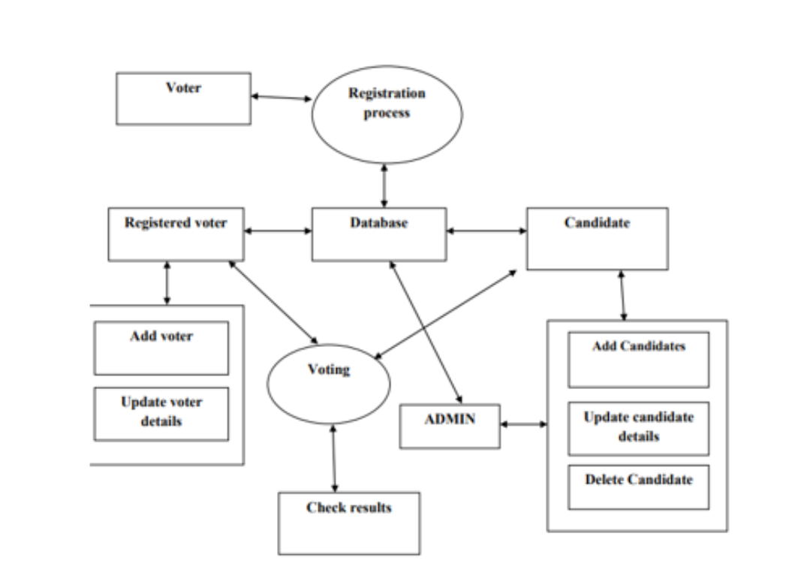

* + 1. **Terms and definition**

1. Election: Finish any outstanding work, such as training, documentation, as well as assigning the appropriate teams to handle support requests.
2. Candidate: In election, a candidate is an individual who is running for a position to win.
3. Voter: A user who has the right to vote in the election.
4. Admin: A user who has access the whole system.
5. Vote: It is a preference of expressing in an election by selecting a candidate.
6. Results: The outcome of an election between the candidates.
7. Profile: User account details and preference
8. Authentication: The method to verify the identity of user.
9. Authorization: Access rights to the users based upon roles and permission within the system.
10. Dashboard: GUI which is shows the homepage showing the information
    * 1. **Functions and features**
11. Create Election: From the authorized users given by the admin, there is availability of creating new election by specifying details such as title, start and as well as end date.
12. Adding Voter taking from user: From the authorized user we can give user who can vote or who cannot.
13. Generates Results: From the election we can see the results.
14. Add admin: There is availability of permitting existing administrators to new administrators.
15. Login: There is availability of users to authenticate themselves by providing valid information.
16. Update Profile: To modify user profile information such as username, password, email and other information.
17. Dashboard View: Any one can see the view in the dashboard which show the information along with ongoing elections and other things.

This is the foundation of the voting system which function and features.

* 1. **Similar projects**

Public opinion and democracy in university settings are the most significant factors in establishing successful management. Voting is the mechanism by which individuals express their opinions and have the ability to pick a leader of their choosing to represent and handle the student's problems. In today's technology and knowledge era, computer-related issues are becoming more common. E-voting is one among these substances, and it is capable of providing adequate, low-cost, rapid, and secure services. The purpose of this article is to demonstrate an electronic voting method (E-Voting) that will be used by the Muni University student electoral body. Several security features were implemented within the E-Voting system to improve performance, speed, and accuracy. (Habibu & Sharif, 2017)

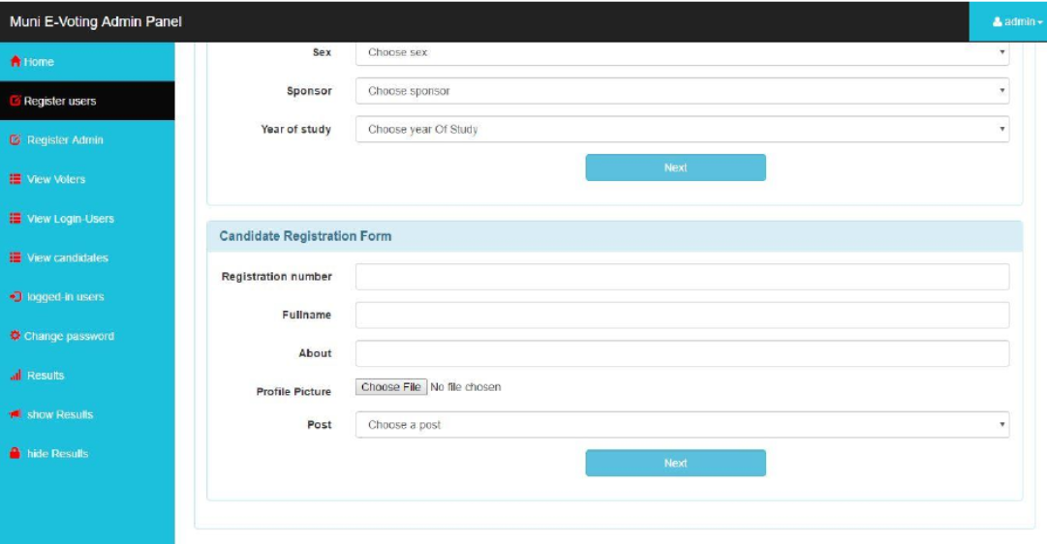

Figure 1- admin panel

The online voting system stores and processes election data. One-level authentication approaches are used to enhance security. The authentication method is based on facial recognition. This authentication technique compares a voter's facial picture from registration to a webcam image taken during voting. After the first step of authentication is completed, voters can cast their votes. These solutions offer a more secure platform, addressing flaws in existing voting systems. We utilize OpenCV, Flask Python module, and the Haar Cascade Algorithm. (P & V, 2022)

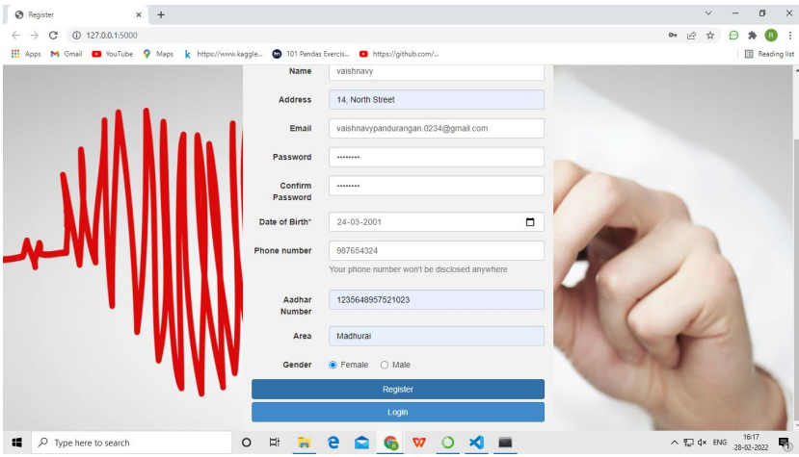

Figure 2 - Registration of Indian Election

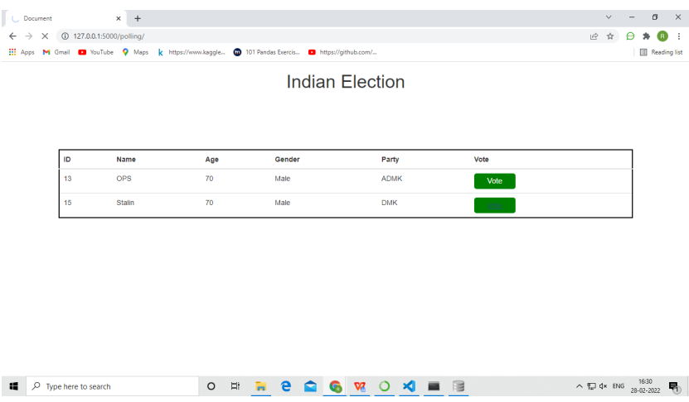

Figure 3-Indian Election

* 1. **Comparison**

|  |  |  |
| --- | --- | --- |
| Function | Voting System | Indian Voting system |
| Facial Reorganization | Disagree | Agree |
| Eligible age for voting | Disagree | Agree |

Table 1 - Comparison of similar projects

**Chapter 3: Development**

1. **Development**
   1. **Considered methodologies**

Software development approaches vary depending on project objectives and goals.  
There are several software development methodologies accessible, giving engineers plenty of alternatives. The bulk of methods belong to one of the following three categories: waterfall, repetitive or continuous.

* + 1. Scrum Methodology

Scrum is an organizational model that allows teams to organize themselves and work toward a common objective. It outlines a series for meetings, tools, and responsibilities for effective project delivery. Scrum techniques(Scrum, n.d.), like a team of athletes preparing for a major game, enable teams to manage themselves, gain experience, and along with adapt to change.

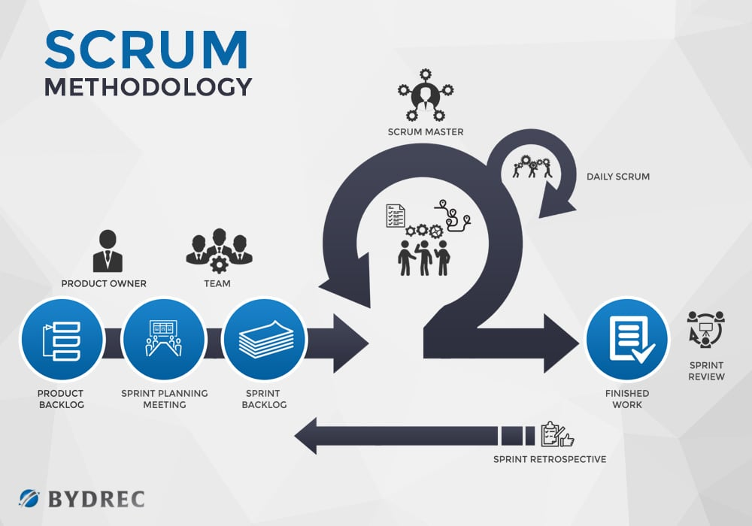

Figure 4 - Scrum methodology

* + 1. Iterative model

The iterative procedure begins with a modest implementation of a portion of the application's requirements and incrementally improves the developing versions until the entire system is completed (Tutorial points). Each iteration involves design changes and the addition of new functional capabilities. The primary idea behind this strategy is to create a system through iterative cycles and in smaller chunks at one time (incremental).

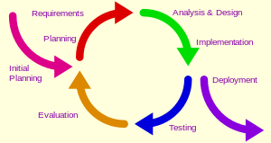

Figure 5 - Iterative model

* + 1. Kanban model

Kanban is a famous agile software development methodology. It is essentially an indicator that directs the movement of parts in a 'pull' manufacturing system established as a component of the Toyota manufacturing System (TPS). Kanban is about visualizing an existing process in terms of stages. The following steps can be made on a whiteboard. (GeeksforGeeks, 2022)

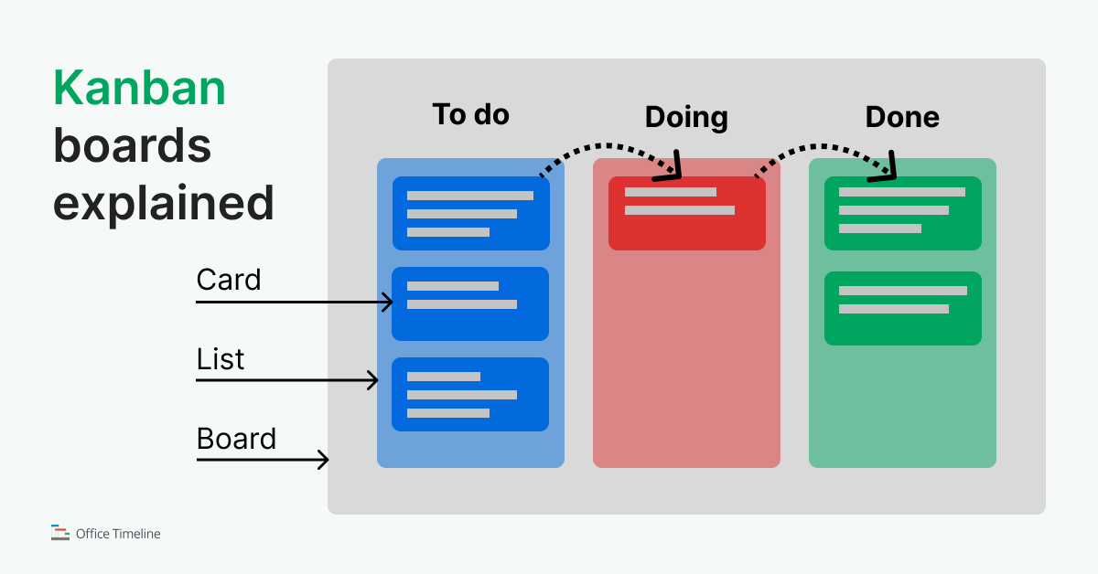

Figure 6 – Kanban

The primary goal of Kanban is to decrease WIP (Work-In-Progress), or inventory, which consists between stages by guaranteeing that the upstream process produces parts for as long as the downstream process requires them. The purpose of Kanban implementation is to guarantee that work items flow swiftly to the following phases, allowing the business to achieve value faster.

* + 1. **Comparison between them**

|  |  |  |  |
| --- | --- | --- | --- |
| Aspect | Kanban Model | Iterative Model | Scrum Methodology |
| Overview | This model provides visual scheduling system which emphasize in continuous delivery and workflow optimization. | It is repeating involvement in development phases in cycles which produces deliverable in increments | This emphasize in collaboration, transparency along with adaptability. |
| Process | Its work items represented as cards on a board with columns which also represents as workflow stages. | The phases has include in planning, requirements analysis, design, its implementation, testing along with deployment | This is organized into time box called sprints having roles and ceremonies. |
| Flexibility | This has been offering flexibility in priorities and changes in real time while accommodating. | This model provides flexibility while iterative refinement along with adaption to changing requirements. | Within the framework of fixed sprints and defined role |
| Continuous Improvement | It limits work in progress and optimize workflow efficiency | Through iterative development stakeholder feedback | Through regular reflection and adaption. |
| Metrics | It depend on metrics like cycle time and other to monitor and improve the work flow | Use metric to track progress, quality and stakeholder satisfaction during iterative cycle | It employs artifacts |
| Feedback Loop | Focus on real- time feedback to overcome bottlenecks and workflow efficiency | Mainly focus on feedback from stakeholders also guide in iterative development. | Regular meetings and ceremonies including sprint review and sprint retrospective |
| Risk Management | By identifying and addressing bottle necks in the works, It supports risk management. | Identify though iterative development, so have early stakeholder feedback and risk mitigation plan. | Early and continuous delivery of potentially shippable increments and regular stake holder engagement helps to manages the risk |
| Delivery Approach | Focus on continuous delivery and flow of work with no predefined iteration cycles. | Delivery functionality in iterations with predefined iteration cycle | Into time-box iteration which has organizes work |

Table 2 - Comparison between the methodologies

* 1. **Selected Methodology**

DSDM Methodology

The Dynamic Systems Development Method (DSDM) is an agile project delivery paradigm used to build software and information systems. The DSDM (Dynamic Systems Development Method) is a systematic method to software development that emphasizes progressive and iterative approaches. It encourages stakeholder engagement, takes into account time limits, promotes user interaction, and effectively prioritizes work. DSDM's major purpose is to provide high-quality, user-friendly software throughout budget and time constraints, while also adapting changing business requirements and objectives. DSDM provides direction along the project's life cycle, from early feasibility studies to get and maintenance, by specifying concepts, processes, and project team responsibilities.

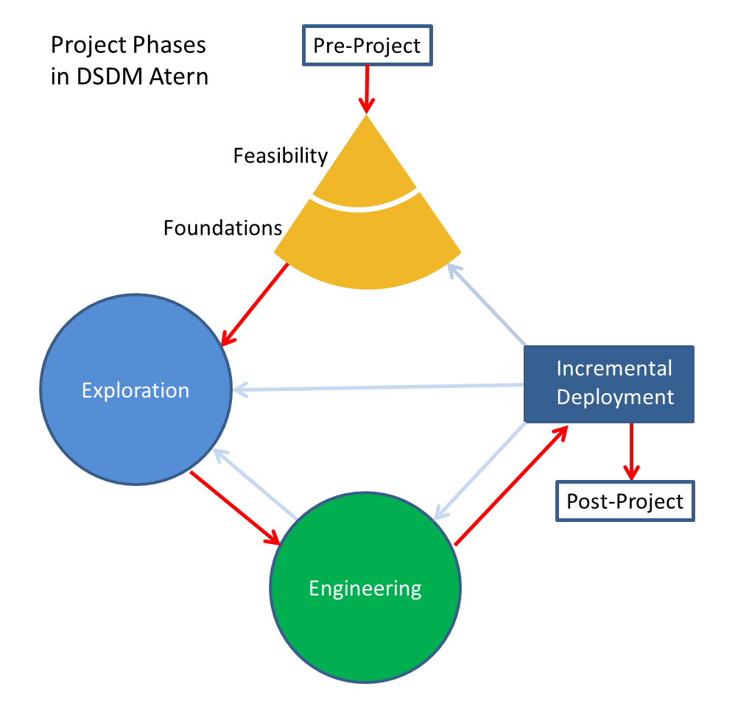

Figure 7 - DSDM

* 1. **Phases of methodology**

The Agile approach that is called DSDM (Dynamic Systems Development Method) which focuses on delivering business value fast while maintaining high quality. Below is a summary of the tasks performed in each DSDM phase:

1. Pre-project:

* Feasibility Study: It determines the project's feasibility, their identification key components, assess risks, along with setting criteria.

|  |  |
| --- | --- |
| Task | Estimated Duration |
| Idea finalization | 10 Sept– 19 Oct |
| Research on topic | 1 Oct – 09 Oct |
| Resource evaluation | 09 Oct – 16 Oct |

Table 3 - Estimated Duration(1)

* Business Study: It recognizes stakeholders, understand the economic environment for business, and develop the project's commercial case.

|  |  |
| --- | --- |
| Task | Estimated Duration |
| Resource re-evaluation | 20 Oct - 27 Oct |
| System architecture evaluation | 28 Oct – 03 Nov |
| Cast evaluation | 04 Nov – 07 Nov |
| Proposal documentation | 07 Nov – 04 Dec |

Table 4 - Estimated duration(2)

1. Planning a Lifecycle:

* In planning there is setting priorities during needs and providing specified time period during development cycles are critical principles in agile development.
* Well defined project's overall strategy, also taking into consideration governance, communication strategies, and roles along with responsibilities.

1. Iteration of the Functional Model:

* Modeling: Create a working prototype of the system, often using user stories or modeling of use cases approaches.   
  Creating prototypes will allow you to check requirements and gather feedback from stakeholders.
* Review and Feedback: It review functional models and prototypes with stakeholders to make sure they meet business needs.

|  |  |
| --- | --- |
| Task | Estimated Duration |
| System architecture design | 30 Nov – 14 Dec |
| Wireframe | 15 Nov – 21 Dec |
| prototype | 22 Dec – 28 Dec |
| User interface development | 29 Dec – 14 Jan |
| Backend development | 15 Jan – 09 Feb |
| Database Integration | 10 Feb – 20 Feb |

Table 5 - Estimated Duration(3)

1. Design and Build Iteration:

* Iterative Development: Iterative development involves developing features in tiny, rapid iterations that often take a few weeks. The primary goal is to provide incremental value during the design and construction iteration phase. This strategy allows teams to continually analyze, alter, and improve their work, ensuring that it meets the needs of stakeholders and adjusts to changing requirements.
* Continuous Integration: For integration time to time, there is frequently merging to the code to make certain a new features work as a whole.
* Testing: here is continuous which will help you detect and issue problem early in the iteration.

|  |  |
| --- | --- |
| Task | Estimated Duration |
| Unit Testing | 21 Feb – O7 Feb |
| System Testing | 08 march – 03 Apr |

Table 6 - Estimated Duration (4)

1. Implementation :

* Deployment: Provide users with completed increments, make sure the system is installed without snags and that users are assisted and trained.
* Advantages Realization: Calculate and check the benefits of the implemented changes, and solicit feedback for future enhancements.

|  |  |
| --- | --- |
| Task | Estimated Duration |
| Collecting feedbacks | 03 Apr – 10 Apr |
| Upgrading and adjusting document | 10 Apr – 17 Apr |
| Report completion | 17 Apr – 21 Apr |

Table 7 - Estimated Duration (5)

1. Post-Project:

* After the Project: Project Evaluation Consider the project's accomplishments and areas for improvement, documenting any lessons learned for future endeavors. Activities Following the Project: Finish any outstanding work, such as training, documentation, as well as assigning the appropriate teams to handle support requests.
* DSDM, or Dynamic Systems Development Method, encourages cooperation, communication, and adaptation at all levels of a team. This method enables teams to efficiently handle fluctuating priorities and requirements. By using a business-centric strategy, DSDM guarantees that the supplied solution is aligned with the organization's goals and produces concrete outcomes, supporting project success.

Why choosing this methodology?

Not Agile methodologies may not meet all business needs and may increase project risk. DSDM prioritizes projects above product development and delivery, setting it apart from other Agile approaches. DSDM prioritizes meeting project objectives by addressing business needs and providing solutions. DSDM takes a realistic approach, recognizing the necessity to coexist with current methodologies and standards.   
The DSDM approach is effective for both developing new solutions and enhancing current ones.

* 1. **Survey results**
     1. **Pre-survey results**

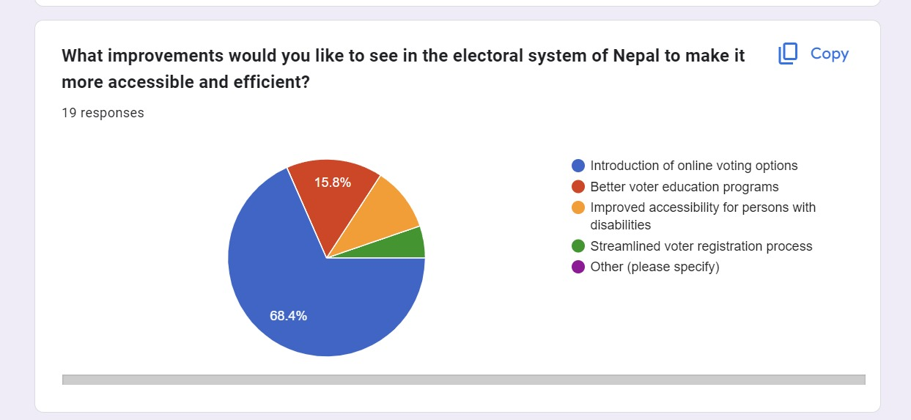

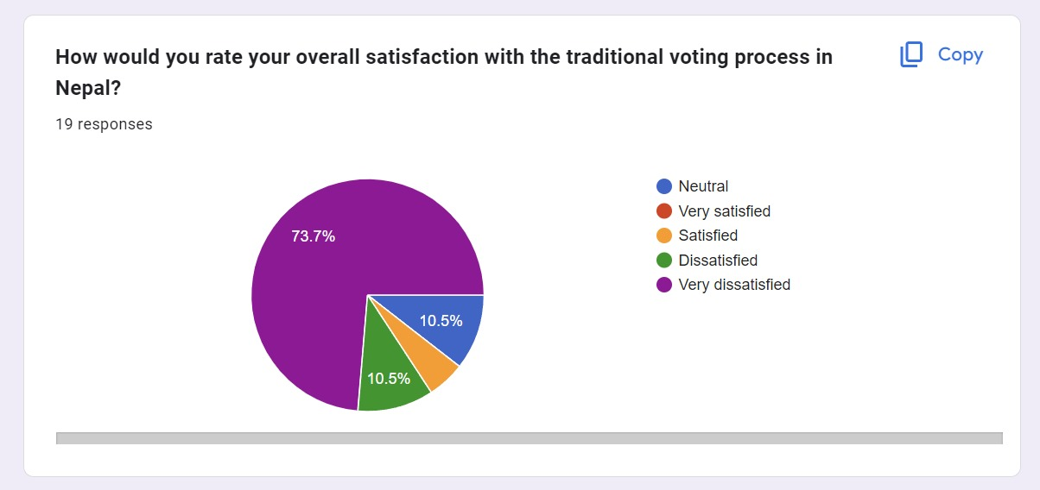

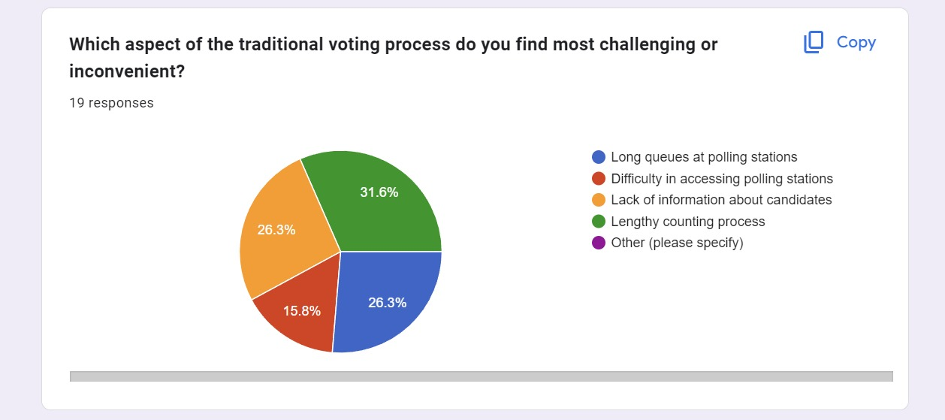

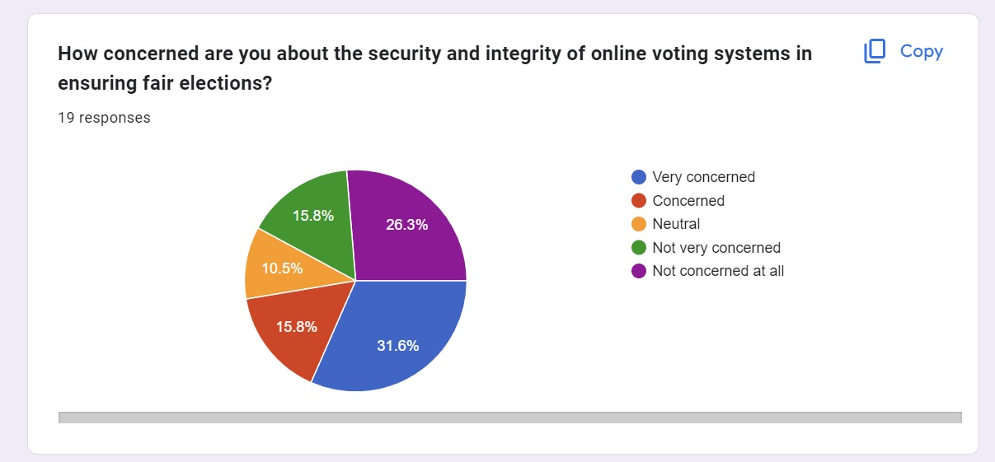

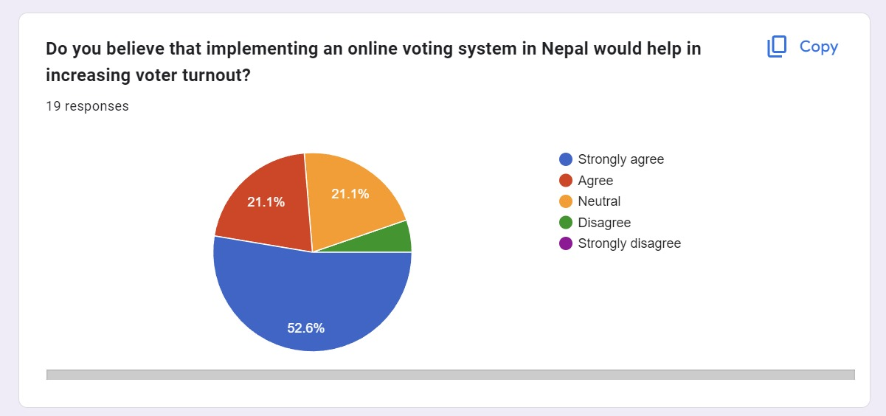

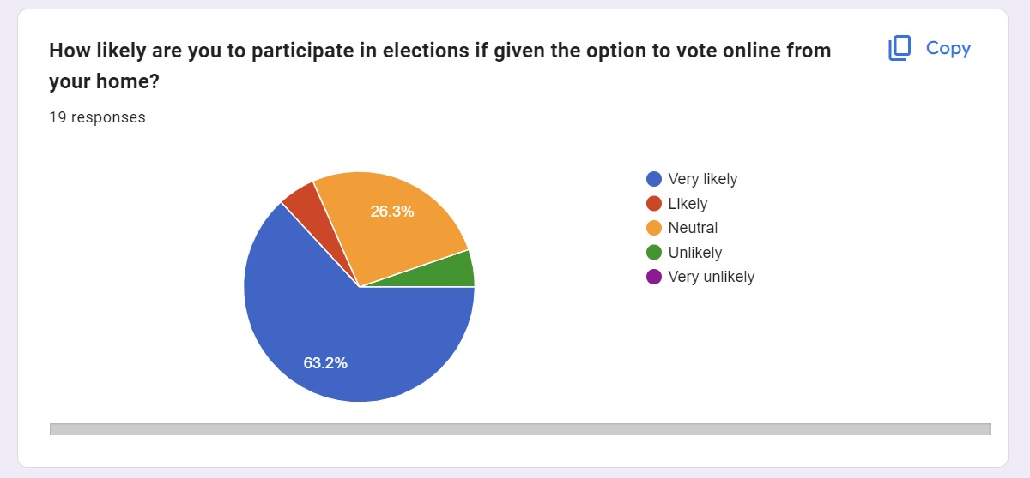

* + 1. **Post- survey results**

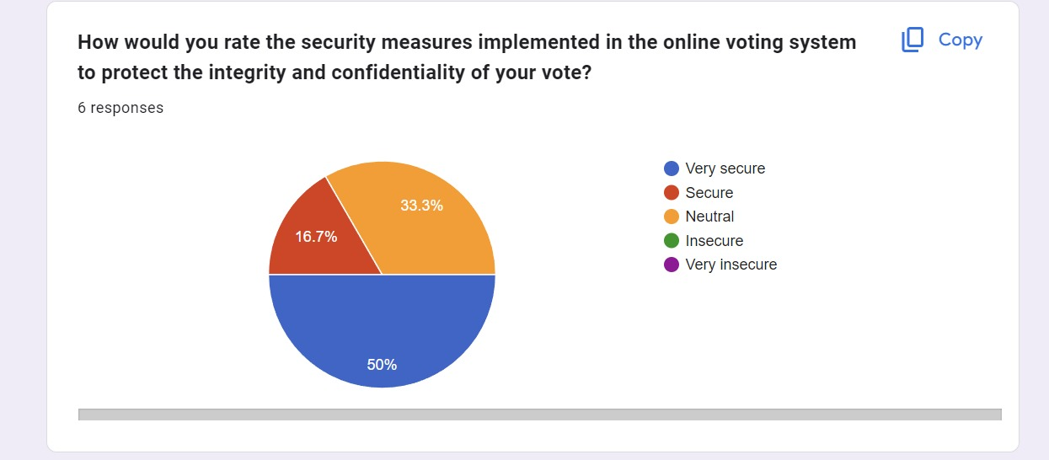

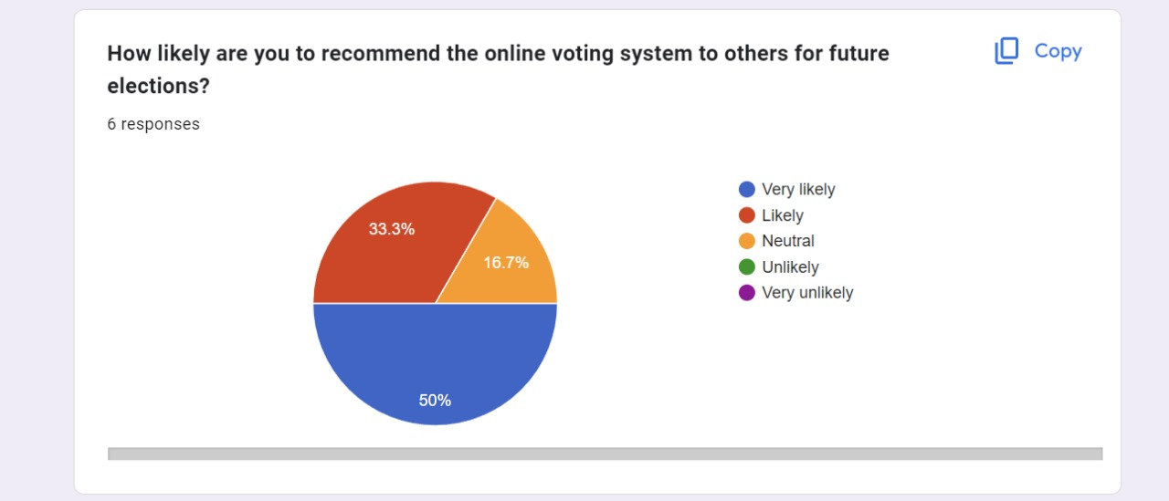

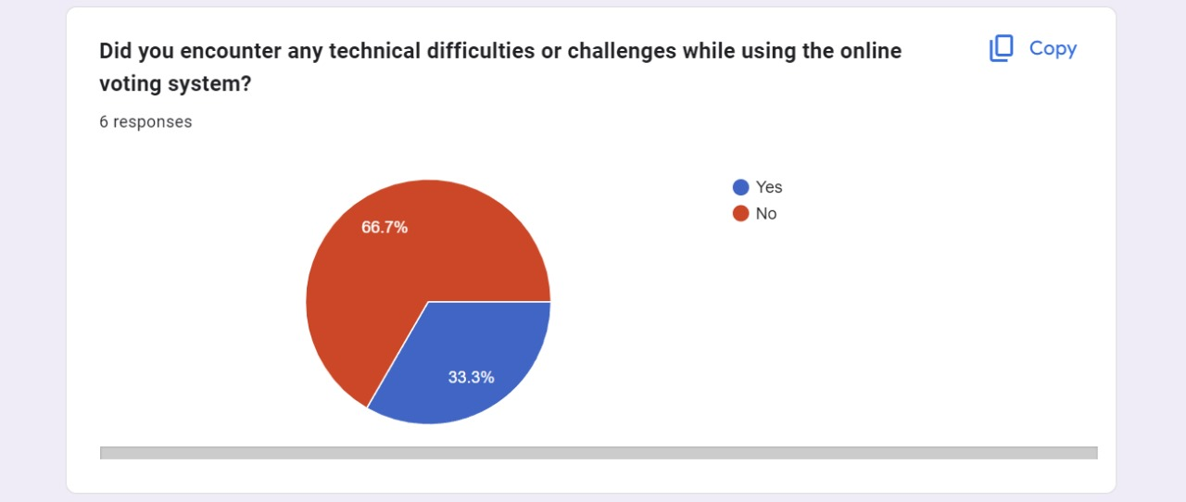

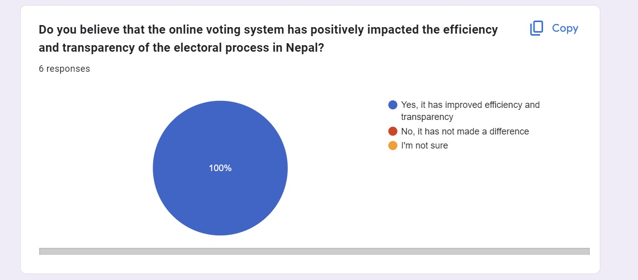

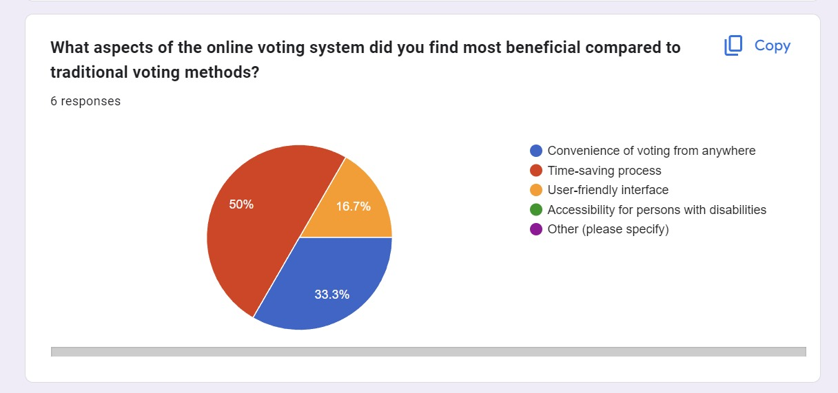

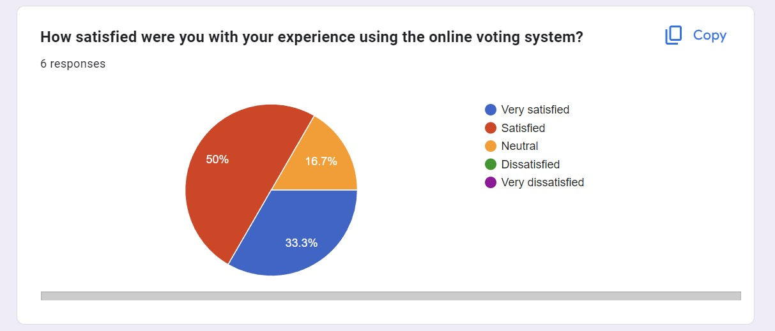

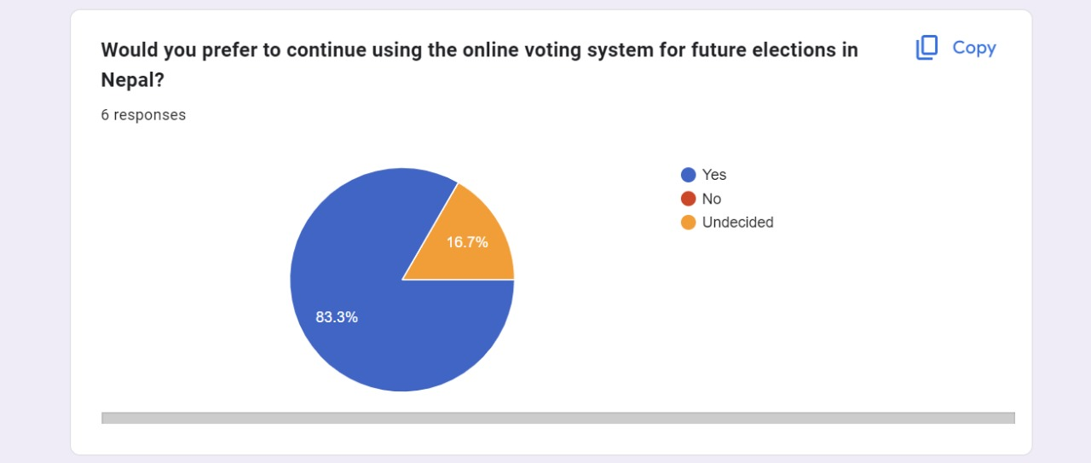

* 1. **Requirement Analysis**

**Software requirements**

* Visual studio code for development process
* Mock flow for wireframe
* MS-word for documentation
* Draw.io for charts and diagrams
* GitHub to keep backup of the project.
* Instagantt for develop Gantt chart
* Any browser to access the website

**Hardware requirements**

* PC for the development requirements. For developing application and documentation

**Languages**

Django – backend for the application

**Other requirements**

* Internet connection for research, and to open web-application as well as development process
* Database

**Platforms to be used in the project**

* **Django**

Django is a framework written in Python which makes it easy to build websites with Python.   
Django handles the tough tasks, allowing you to focus on developing your web applications. One of the main feature about Django frame work is we can create the default admin panel. This has made suitable for developers in the web development.

**SRS documents**

**Introduction**

Nepal lags behind in terms of appropriate education and economic development. Infrastructure such as power, internet, and other services are not widely available throughout the country. Despite the fact that the initiative has the potential to be successful in the available portions of Nepal.

* 1. **Design**

A design is a notion or concept for a product, method, or system. Design describes something that was or has been purposefully made by a creative agent, yet it is also used to describe the essence of something - its design. The verb of design describes the process of creating a design. In certain circumstances, the direct fabrication of a product without an explicit previous plan may be called design (for example, arts and crafts). A design is supposed to serve a purpose inside a certain setting, typically meeting specific goals and limits but also taking into account aesthetic, utilitarian, economic, environmental, or sociopolitical issues.

For further description of the system design, following things are described.

* + 1. **Gantt Chart**



Figure 8 - Gantt Chart

<https://app.instagantt.com/shared/6628286d41670d12d33c1ece>

* + 1. **Logo**

The logo is simply design. Online voting system as its short form OVS. And the picture shows about voting ballet. So to encourage the people about giving voting to choose a right candidate there is shown as this icon as well as online voting system.

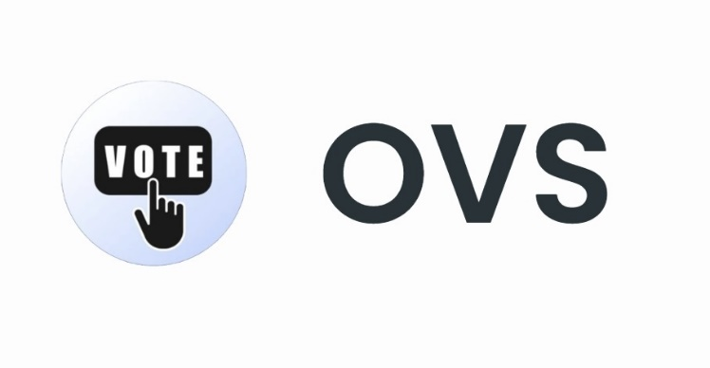

Figure 9 - LOGO

* + 1. **Use Case diagram**

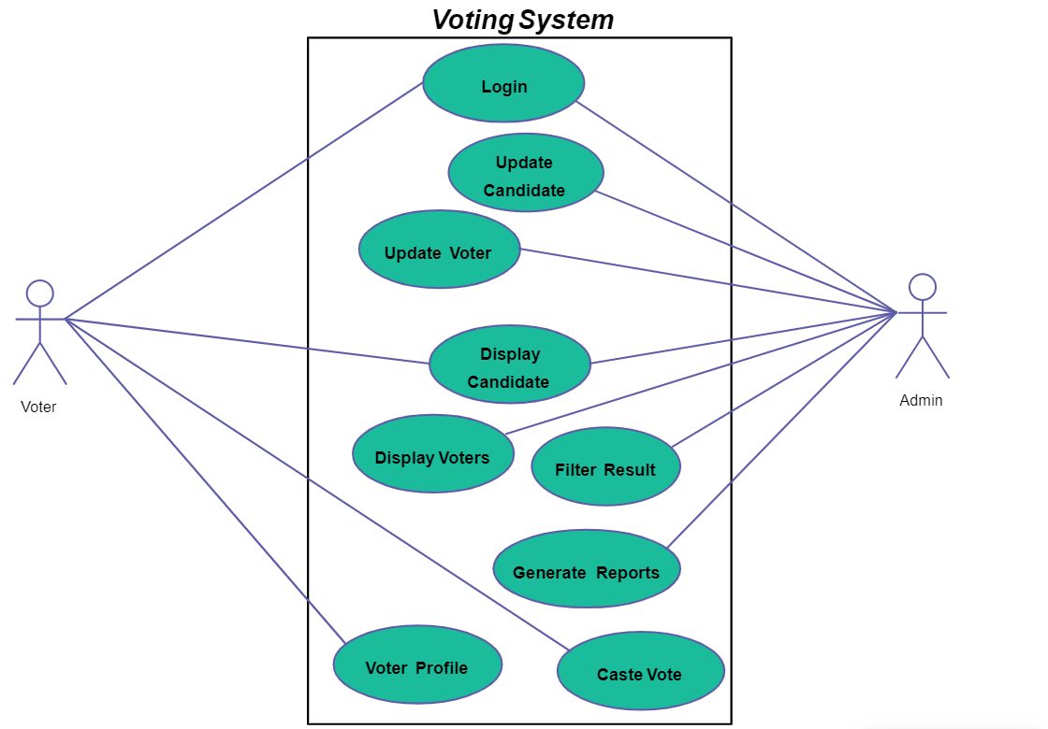

Figure 10 - Use case diagram

* + 1. **Flow Chart**

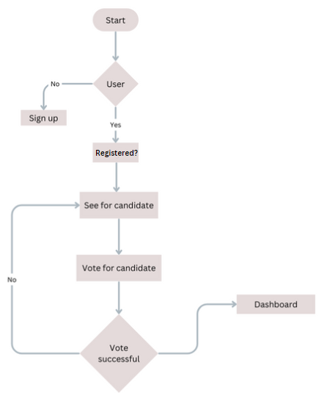

Figure 11 - Flow chart

* + 1. **Dataflow Diagram**

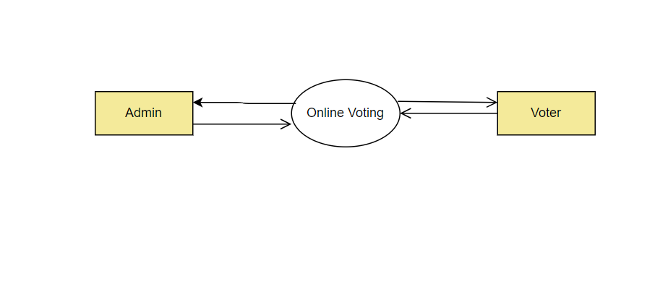

Figure 12 - Dataflow Diagram

* + 1. **System Activity diagram**

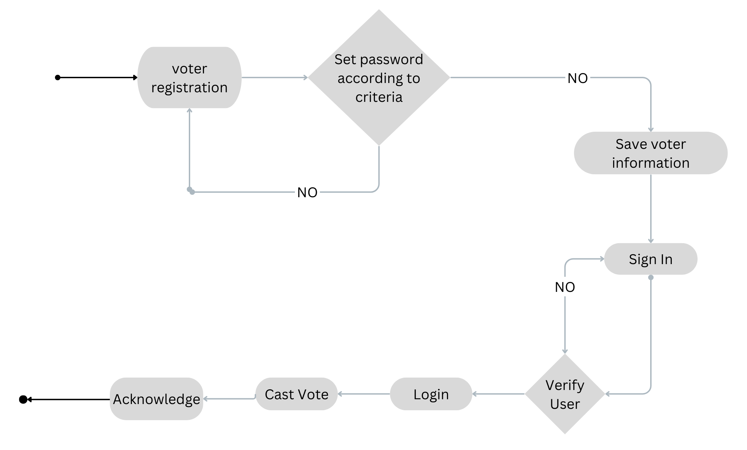

Figure 13 - System Activity Diagram

* + 1. **Class diagram**

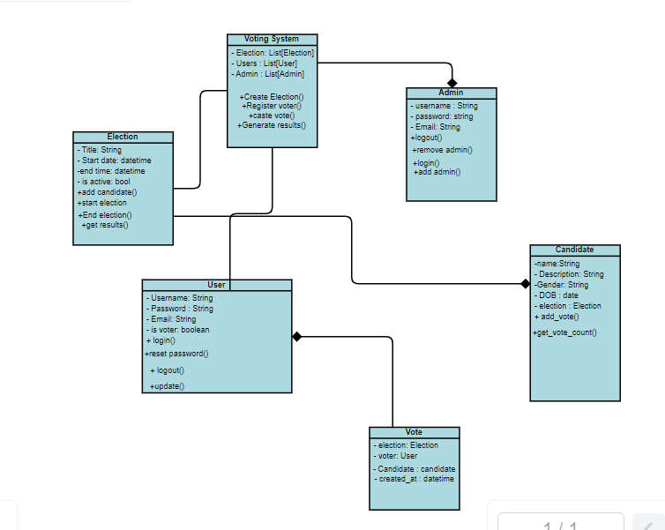

Figure 14 - Class Diagram

* 1. **Graphical User Interface**

A graphical user interface, or graphical user interface (GUI) allows people to engage with a device using graphical icons. Typically, interactions are enabled via a mouse, trackpad, or other point-and-click device. A GUI is represented by the computer's desktop or home panel on your laptop.

* + 1. **Wire Frames**

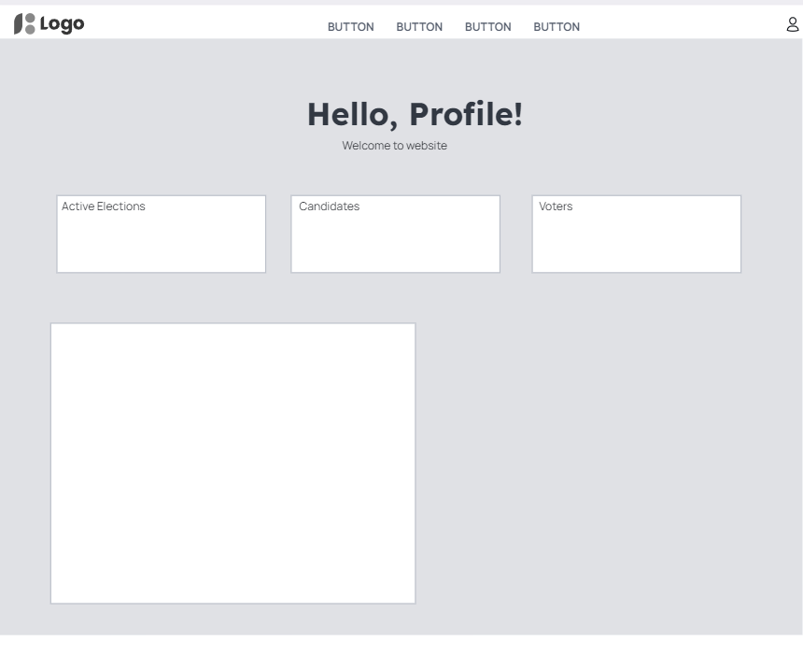

Figure 15- Wireframe of Dashboard



Figure 16 -Wireframe of Sign In

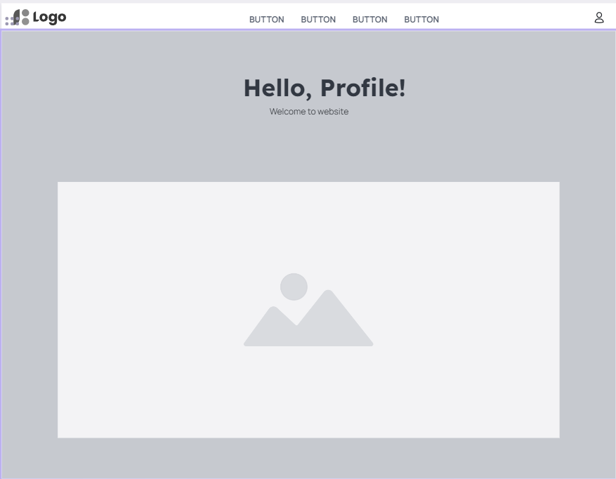

* + 1. **Application Design**

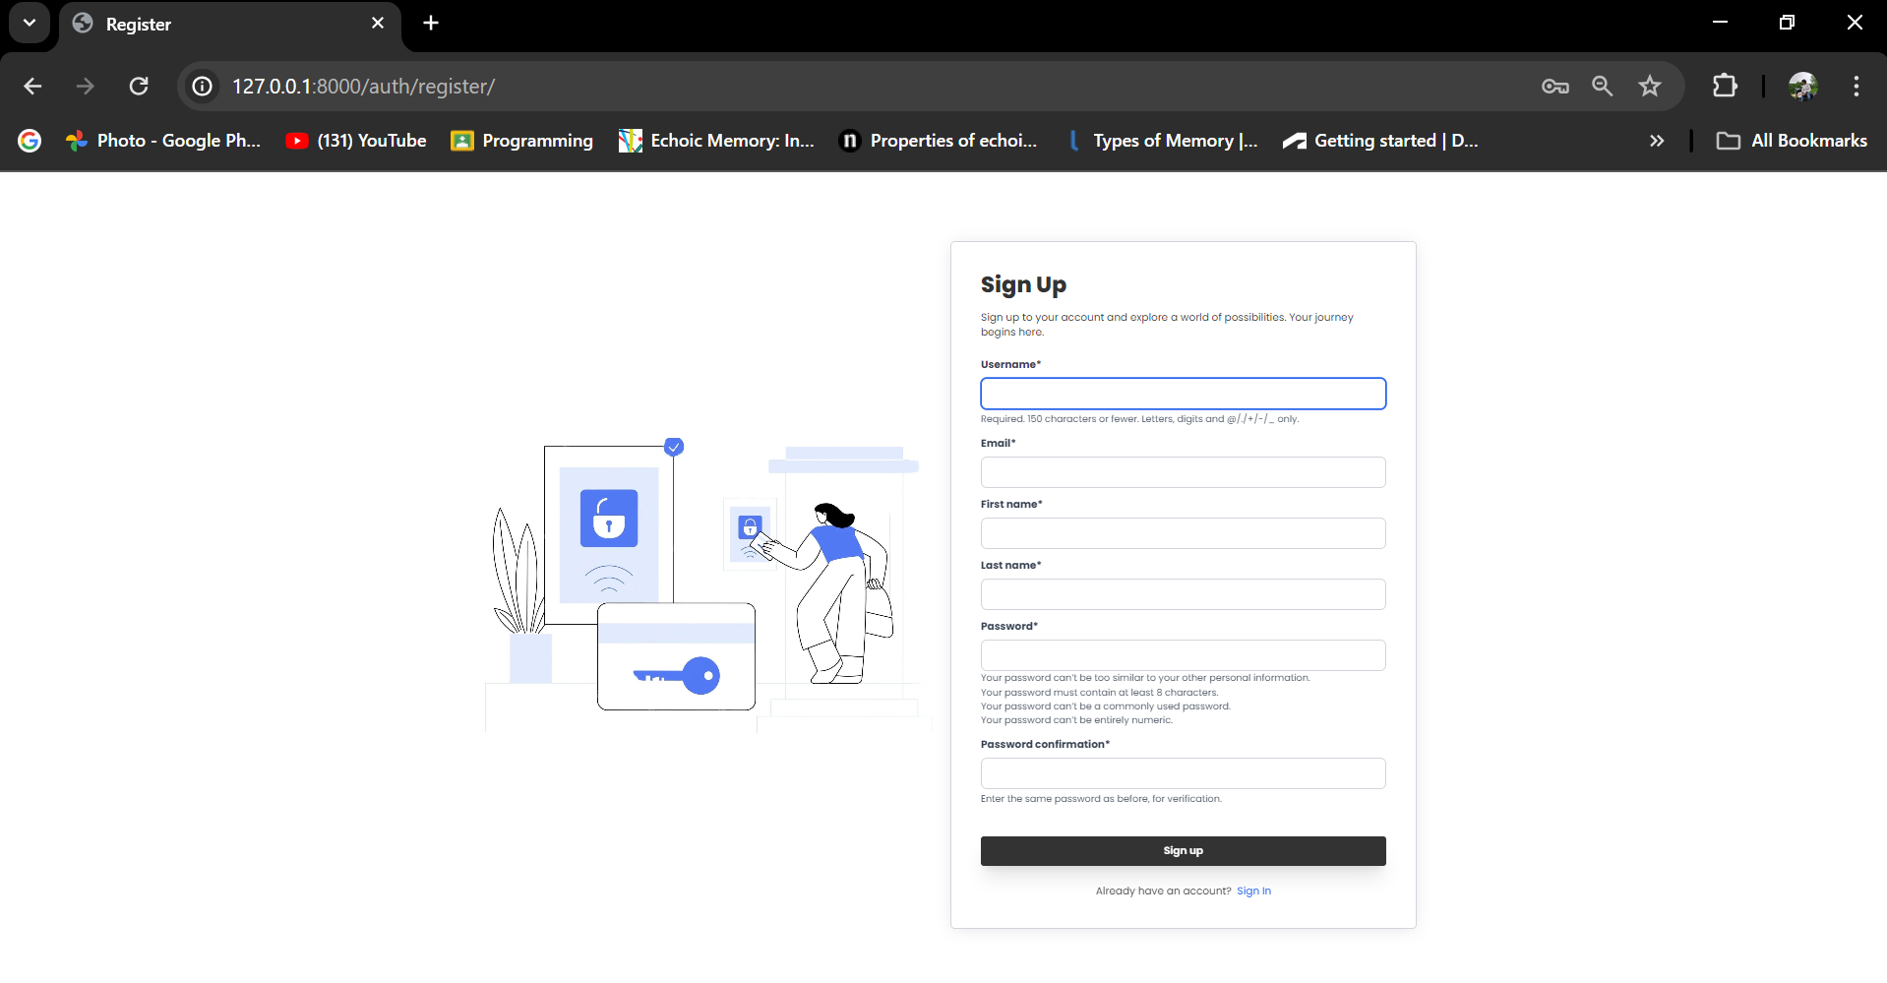

Figure 17 - Application design of Sign up page

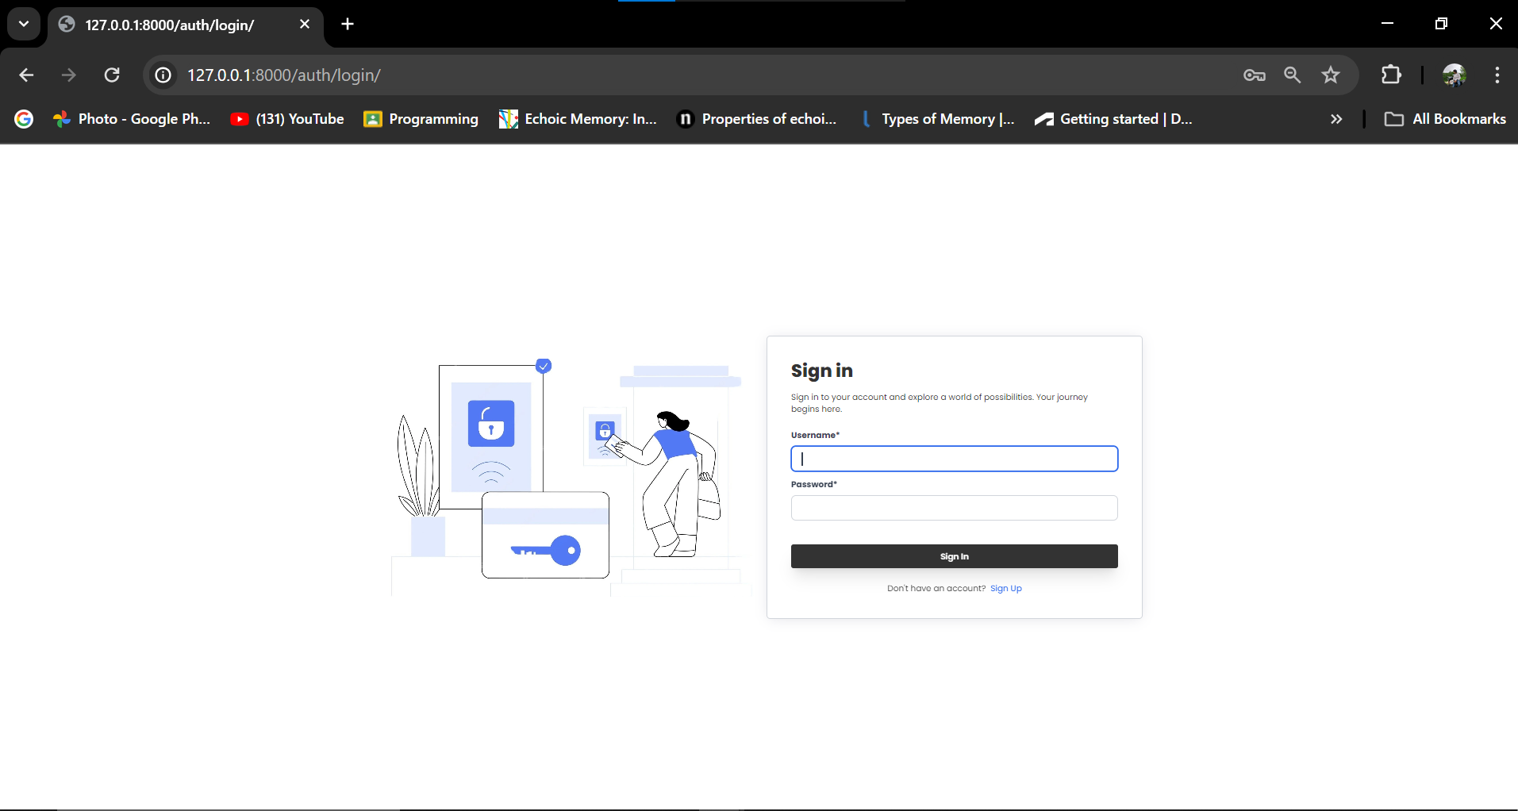

Figure 18 - Application design of sign in page

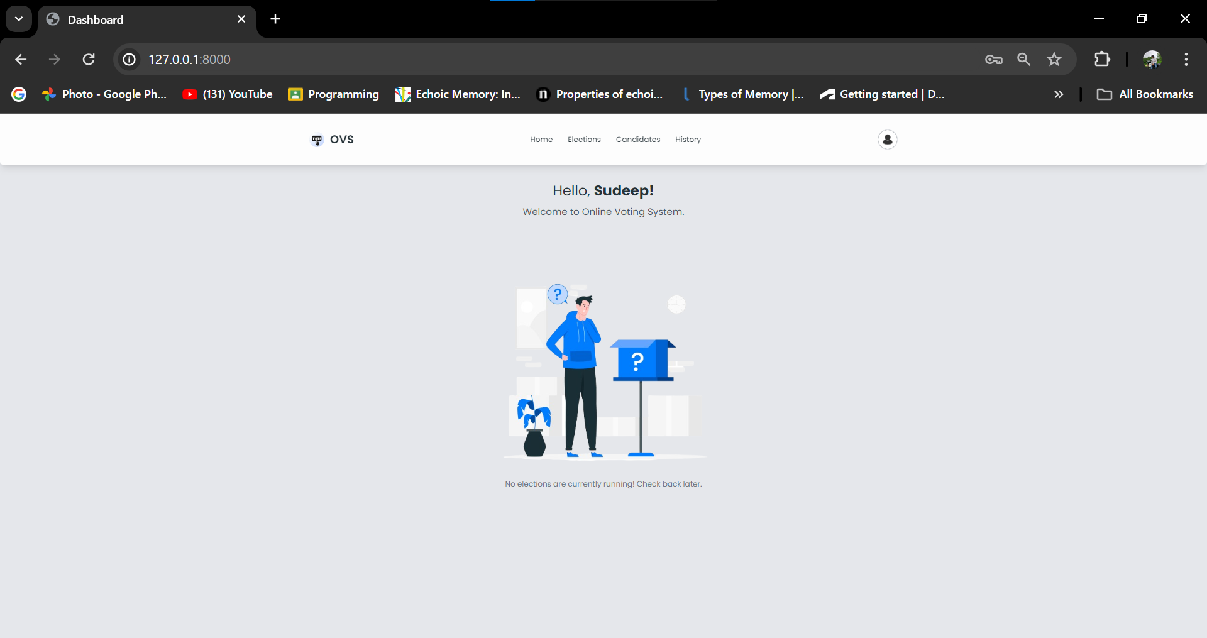

Figure 19 - Application design of dashboard

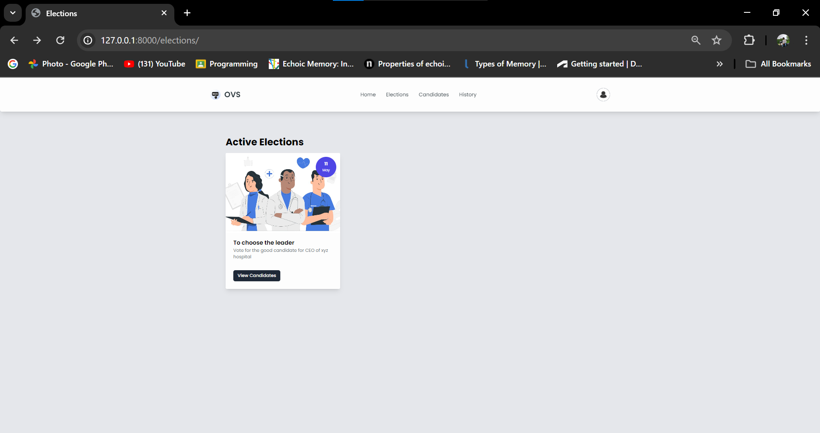

Figure 20 - Application design of elections

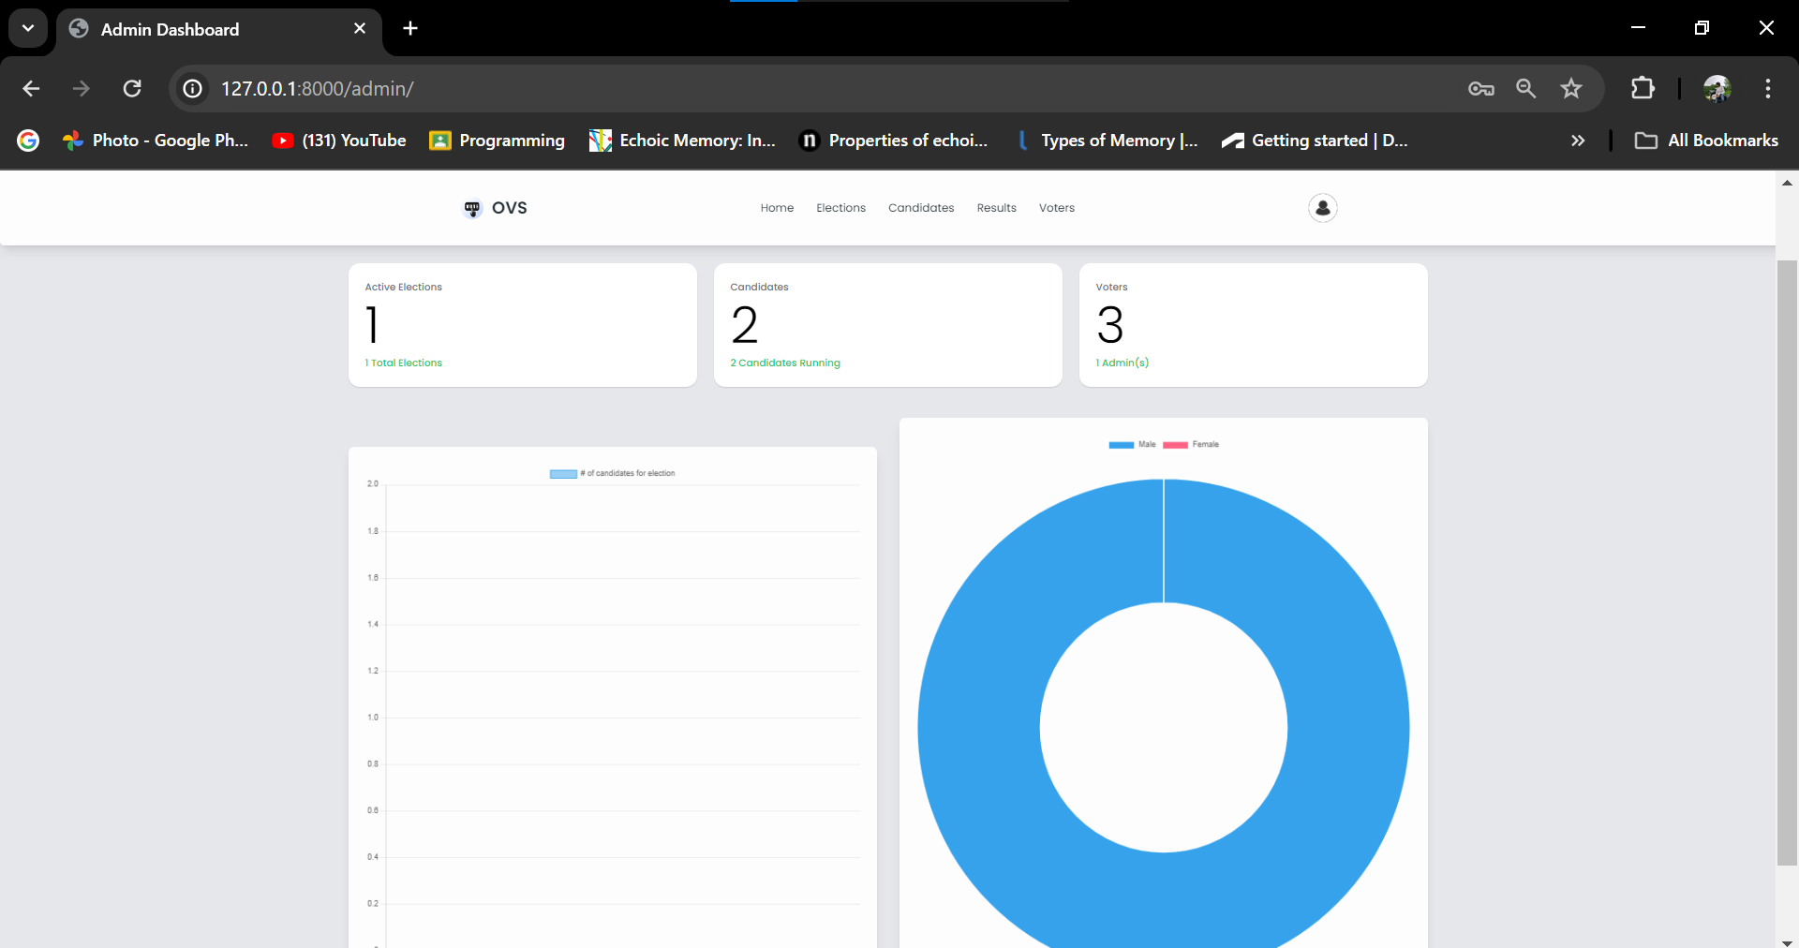

Figure 21 - Application design of candidates

* 1. **Implementation**
     1. **Database design**

Database design is a set of procedures for developing, implementing, and maintaining a company's data management systems. The basic goal of building a database aims to create physical as well as logical models of the database system that is suggested. (Astera. 2023)

* + 1. **Code Implementation**

Some of the code implementation will be shown below. However, for short description about the application made from Django Framework will be description. The application uses Django for backend while the database is stored using MySQL.

For the models of use in the election details:

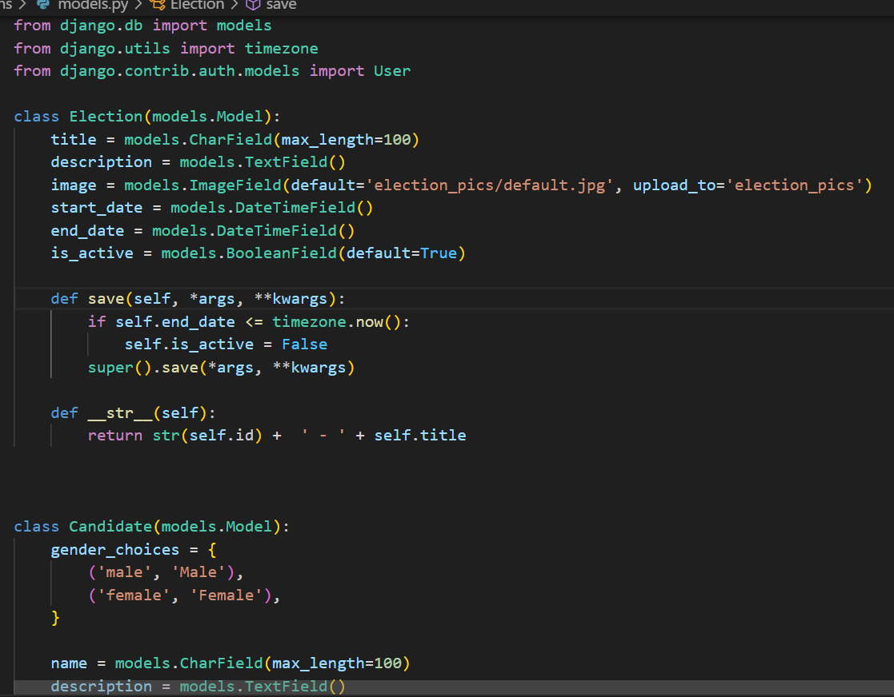

Figure 22 - Models to start the election (1)

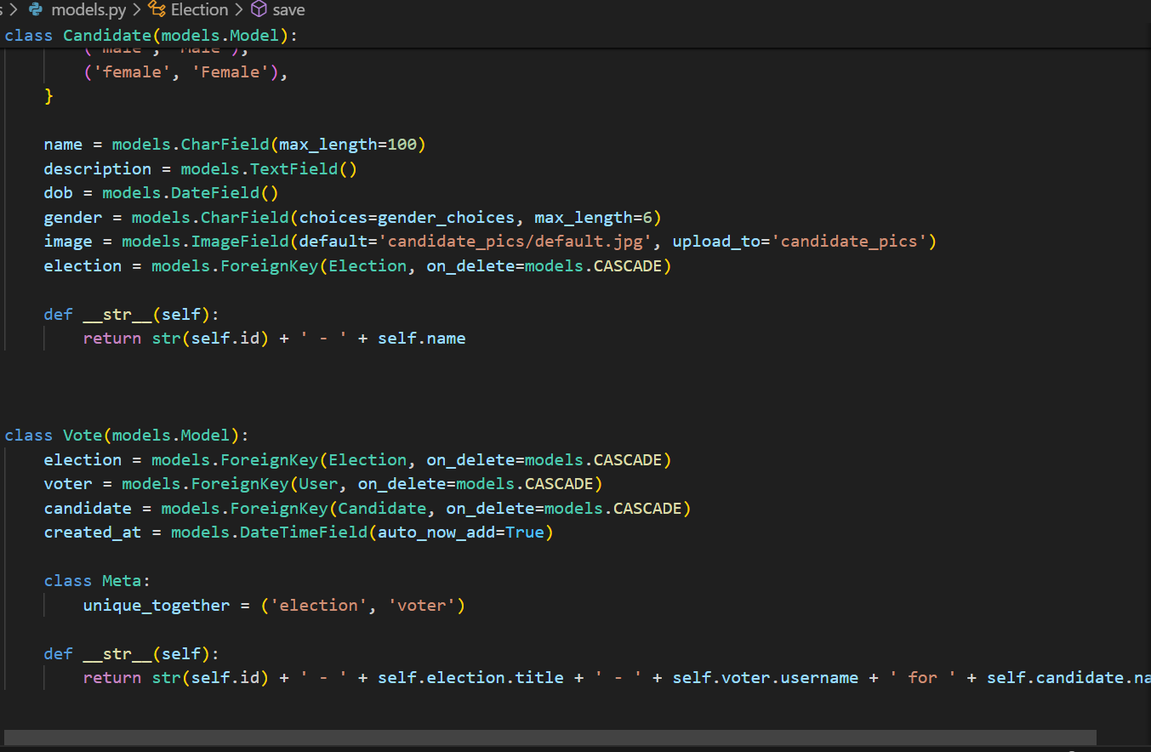

Figure 23 - Models to start the election (2)

To create the model for user:

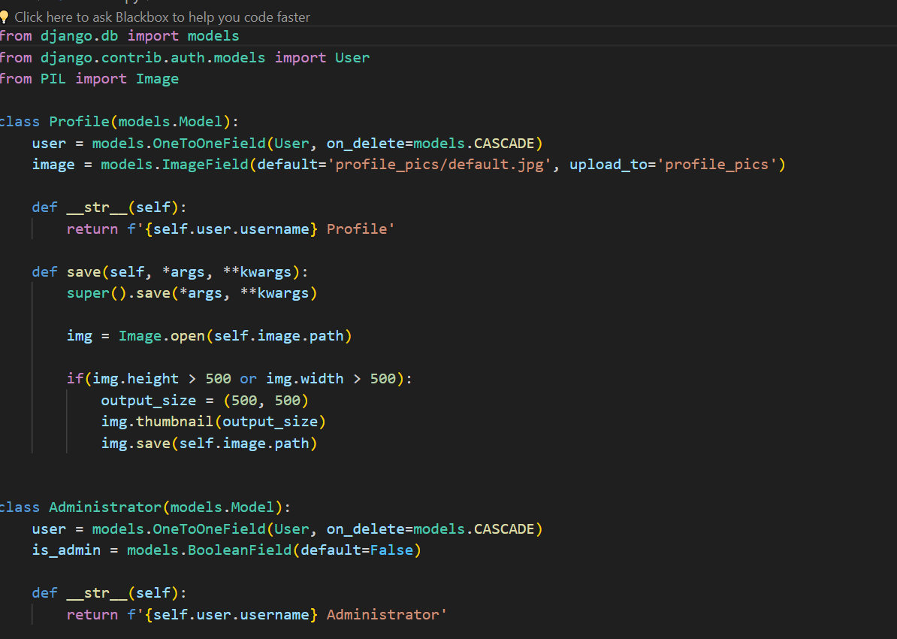

Figure 24 - To create the model for the user

**Chapter 4: Testing and Analysis**

1. **Testing and analysis**
   1. **Test Plan**

A test plan is a thorough document that outlines software testing areas along with actions. It describes the test strategy, goals, test schedule, necessary resources (human, software, and hardware), test estimates, and test deliverables.   
The test strategy is the foundation of all software testing. It is the most important action since it assures the availability of all scheduled activity listings in the proper order.   
The test strategy is a blueprint for carrying out software testing operations as a structured procedure overseen and supervised by the test manager. The test plan is created by the Test Leader (60%), Test Manager (20%), and Test Engineer (20%).

Unit Testing, Plan

|  |  |
| --- | --- |
| Test | Objective |
|  | To test valid login credentials |
|  | To test new election creation with valid details |
|  | To test user’s vote record |
|  | To test the calculation accuracy in election results |
|  | To test the user profile updating |
|  | To test admin dash board control |

Table 8 - Unit Testing Plan

System testing, Plan

|  |  |
| --- | --- |
| Test | Objective |
|  | To test login, register and vote |
|  | To test election lifecycle like create, vote and results |
|  | To test user vs admin roles |
|  | To check the data integrity. |
|  | To test performance testing |
|  | To test user interface Experience |

Table 9 - System Testing Plan

* 1. Unit Testing

1. To test valid login credential

|  |  |  |
| --- | --- | --- |
| Test no | Expected outcome | Status |
|  | Authentication for valid login credentials | Pass |

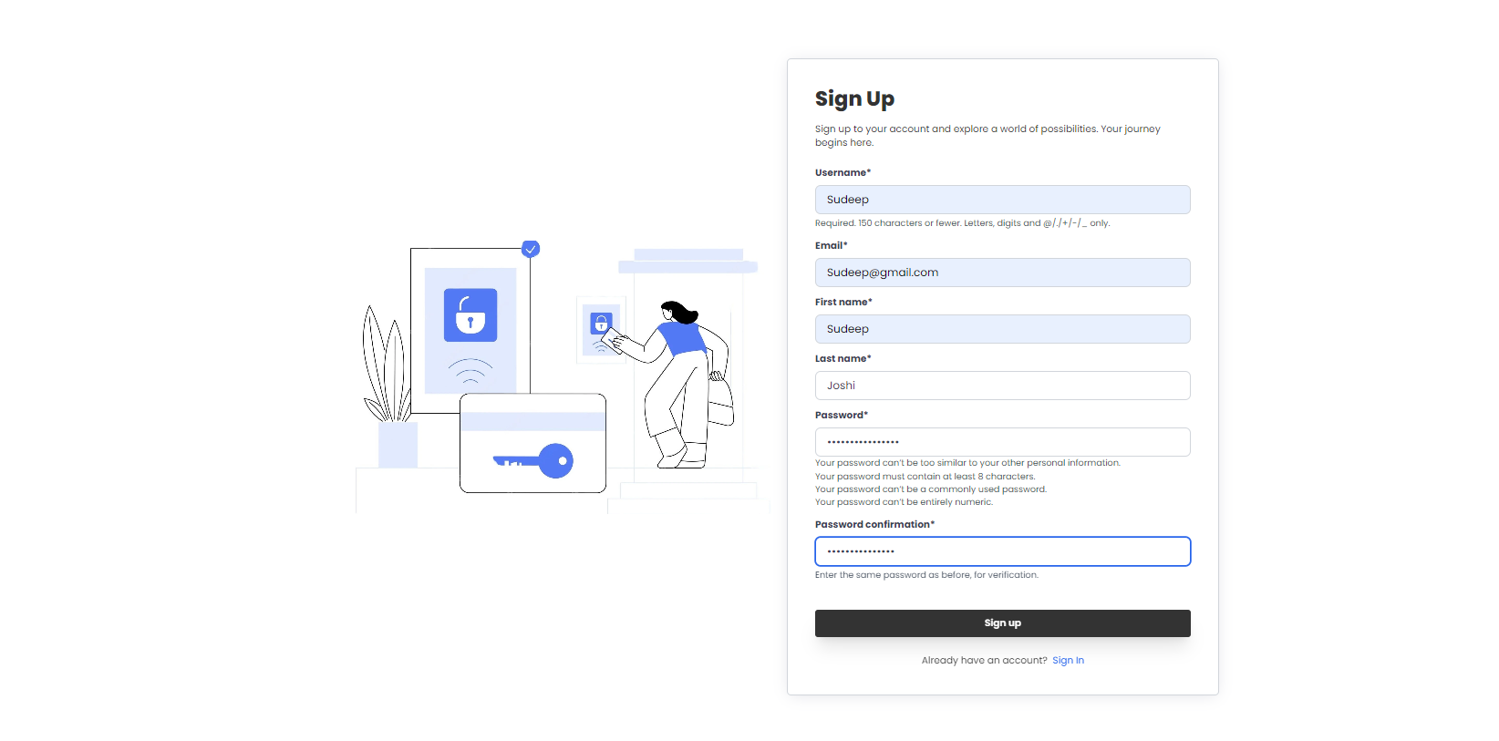

Figure 25 - Unit test(1)

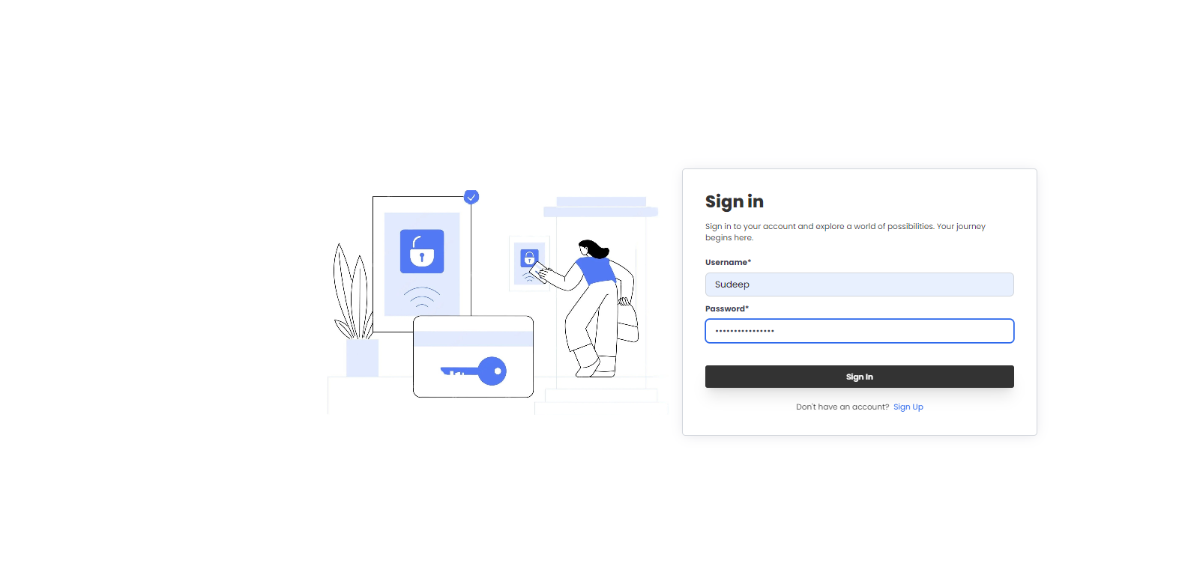

Figure 26 - Unit Test(2)

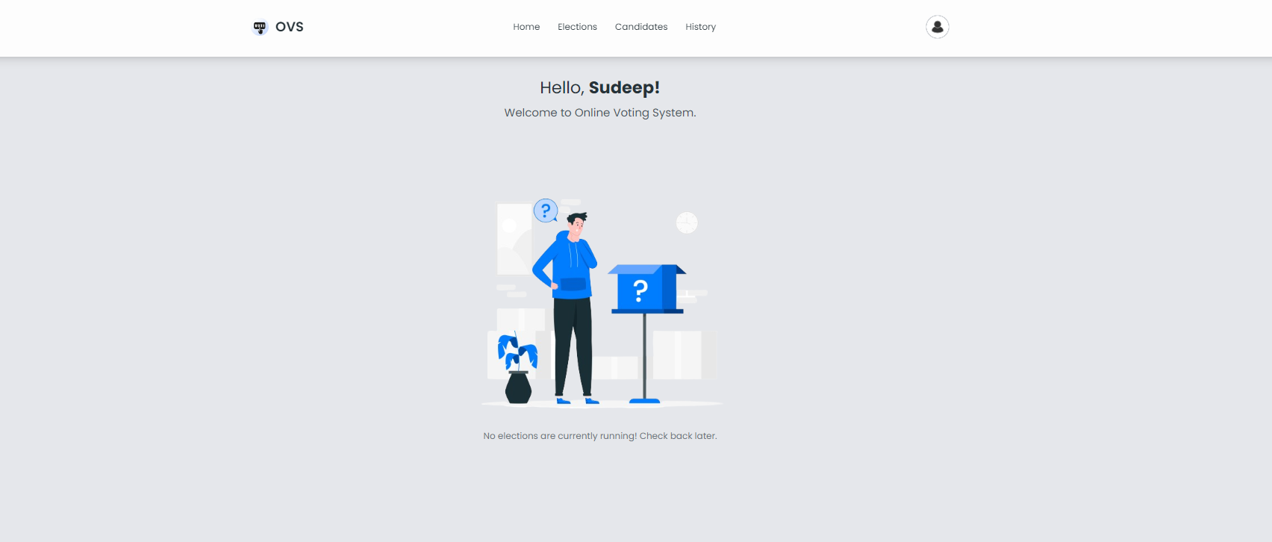

1. To test new election creation with valid details

|  |  |  |
| --- | --- | --- |
| Test no | Expected outcome | Status |
|  | There should be valid election detail | Pass |

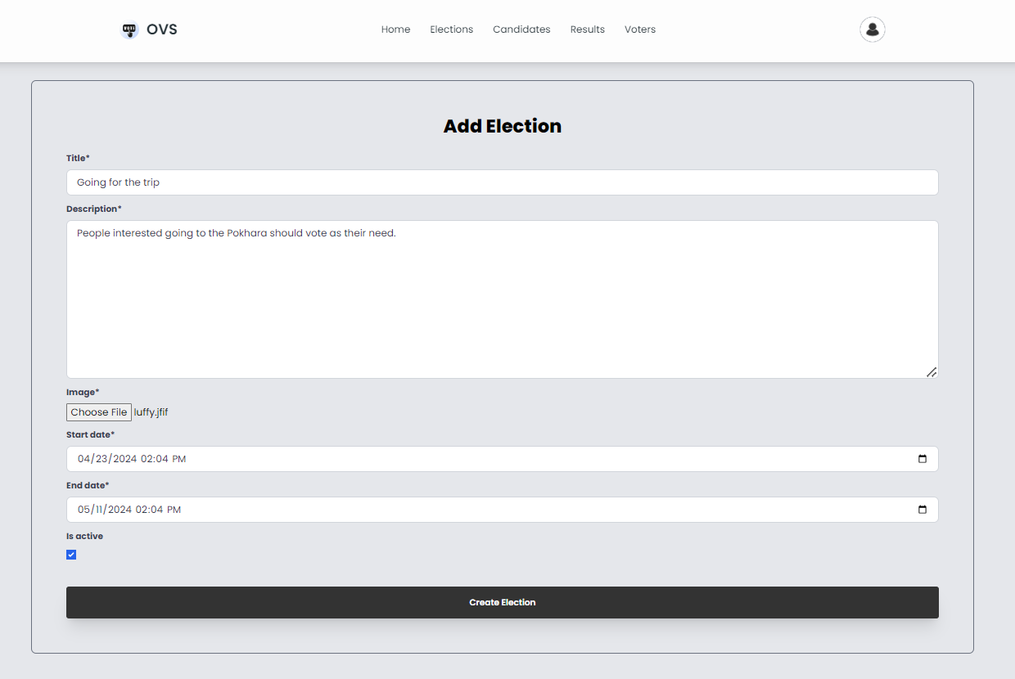

Figure 27 - Unit Test(3)



Figure 28- Unit Test (4)

1. To caste vote successfully

|  |  |  |
| --- | --- | --- |
| Test no | Expected outcome | Status |
|  | There should be vote casting for user. | Pass |

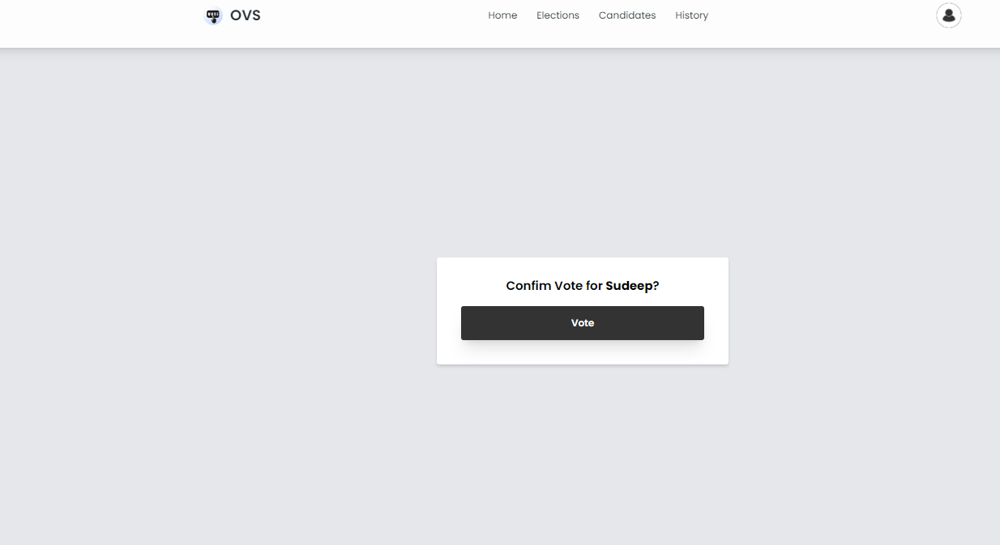

Figure 29 - Unit Test (5)

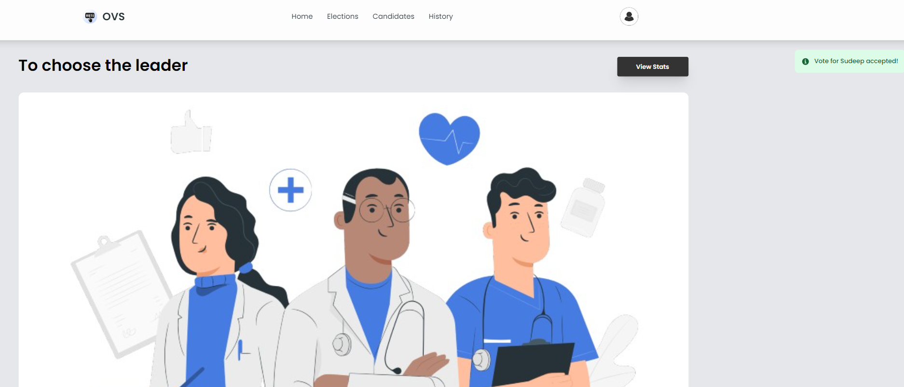

Figure 30 - Unit Test(6)

1. To calculate vote accuracy in results

|  |  |  |
| --- | --- | --- |
| Test no | Expected outcome | Status |
|  | To calculate vote accuracy | Pass |

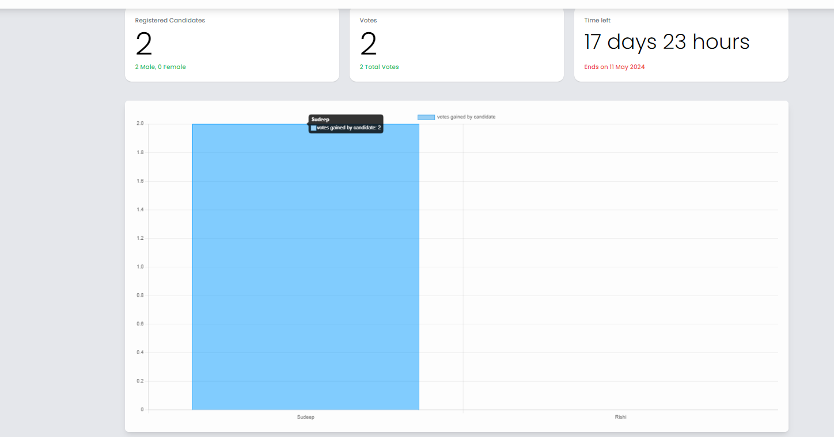

Figure 31 - Unit Test(7)

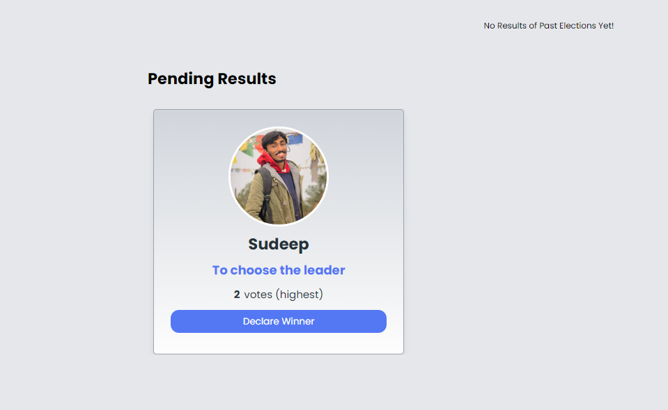

Figure 32 - Unit Test (8)

1. To update profile information

|  |  |  |
| --- | --- | --- |
| Test no | Expected outcome | Status |
|  | There should be update profile information outcome. | Pass |

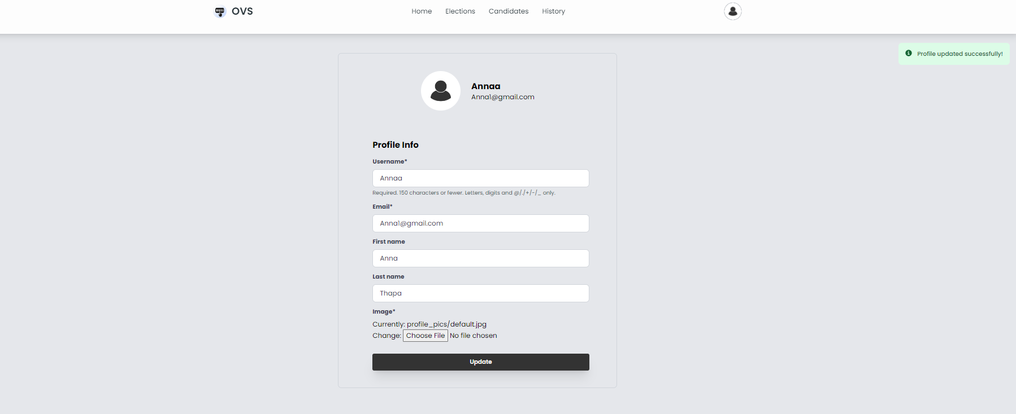

Figure 33 - Unit Test (9)

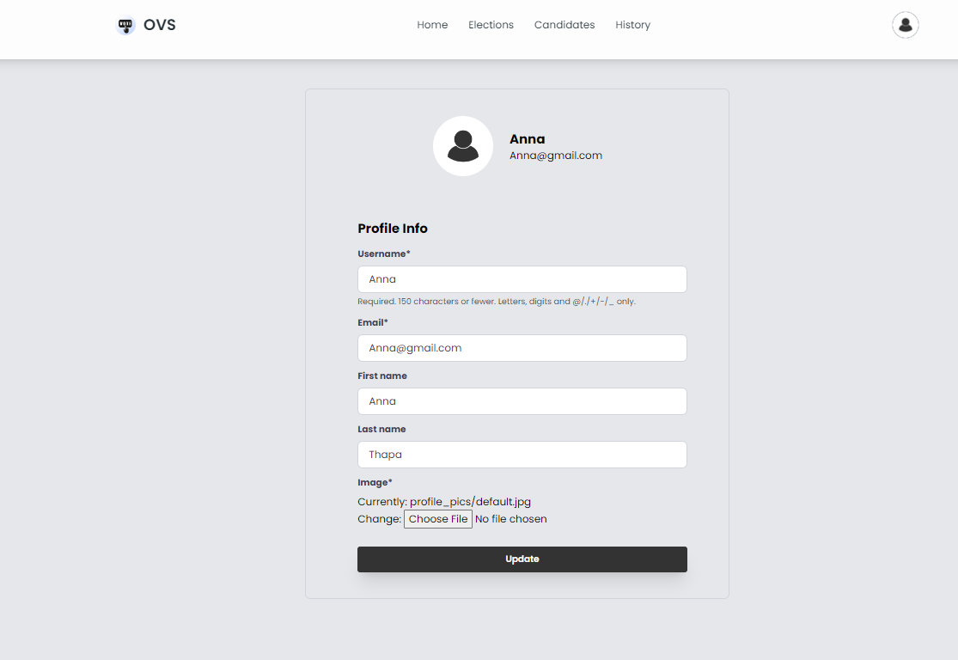

Figure 34 - Unit Test (10)

1. To see the admin control

|  |  |  |
| --- | --- | --- |
| Test no | Expected outcome | Status |
|  | There should be control of admin | Pass |

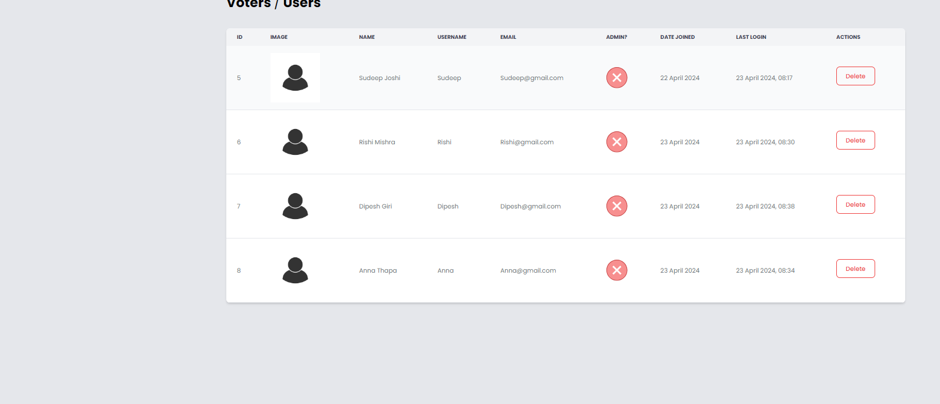

Figure 35 - Unit Test (11)

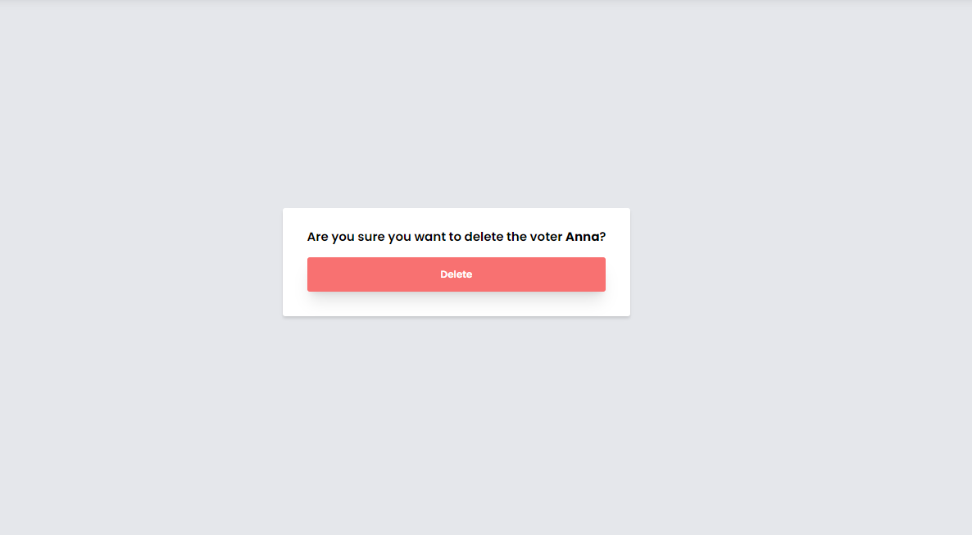

Figure 36 - Unit Test (12)

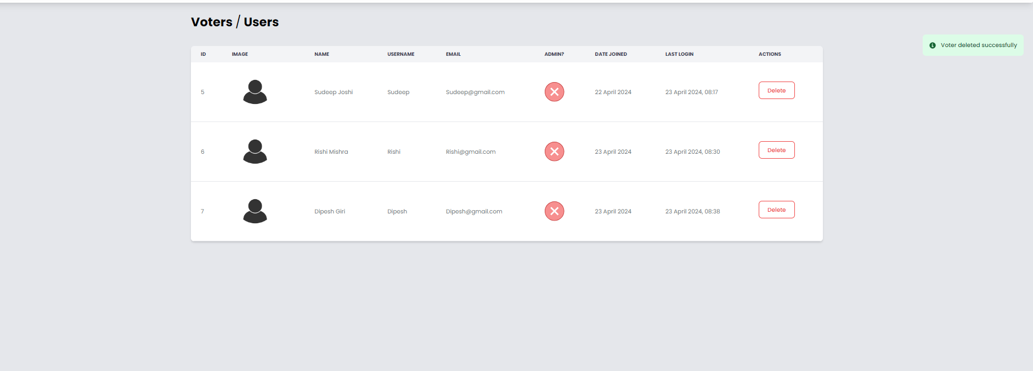

Figure 37 - Unit Test (13)

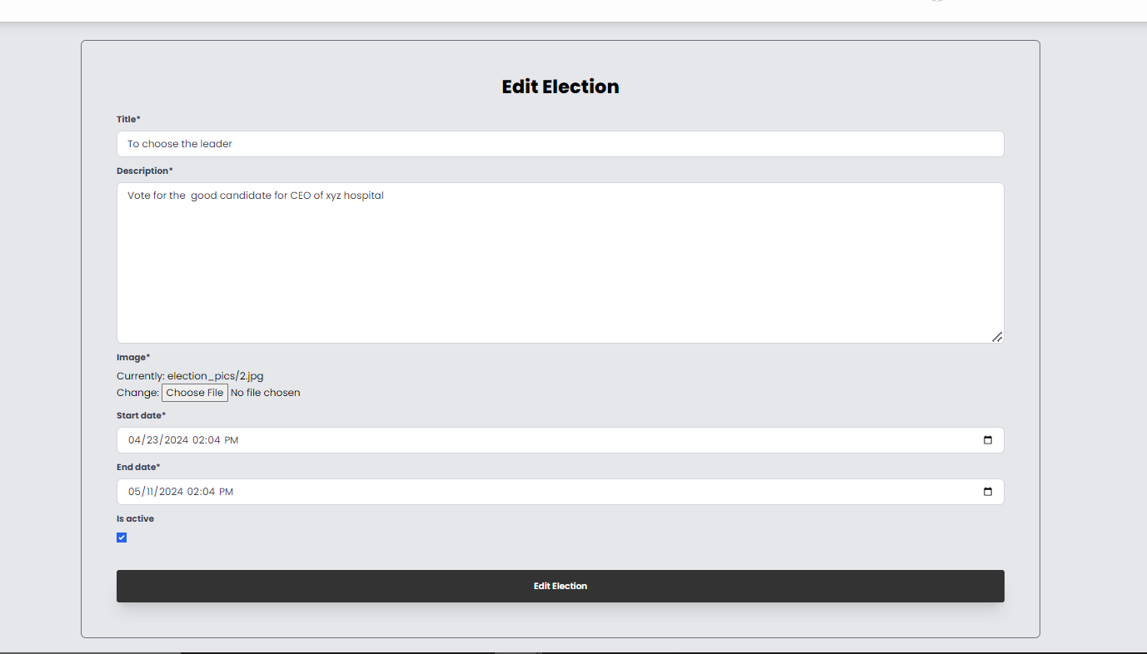

Figure 38 - Unit Test (14)

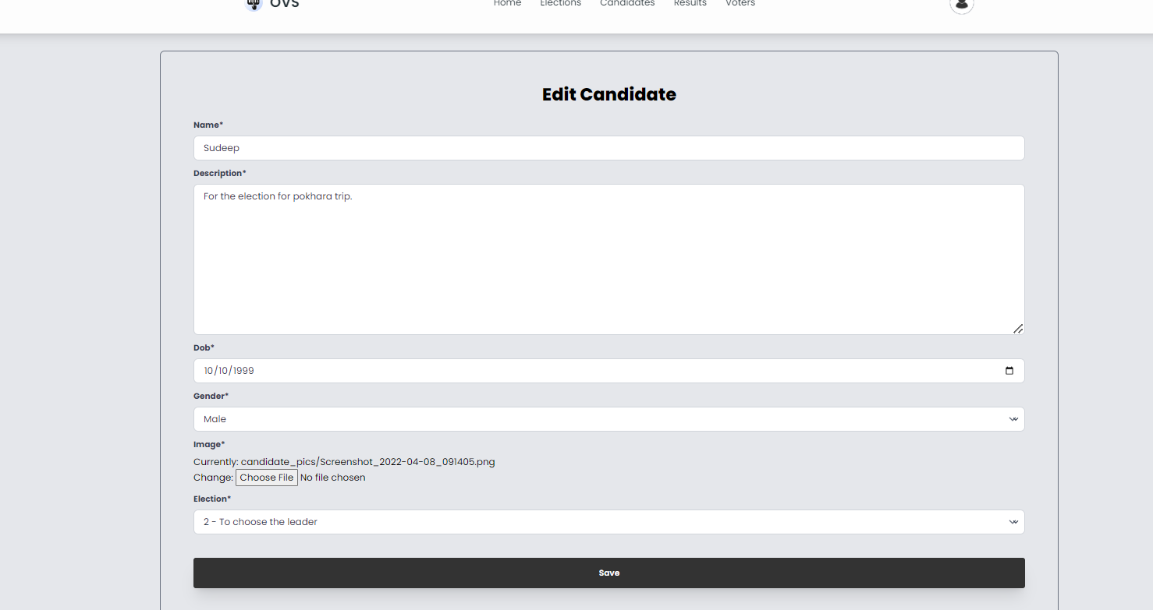

Figure 39 - Unit Test (15)

* 1. **System Testing**

1. To check the user journey

|  |  |  |
| --- | --- | --- |
| Test no | Expected outcome | Status |
|  | User can successfully register, login and vote | Pass |

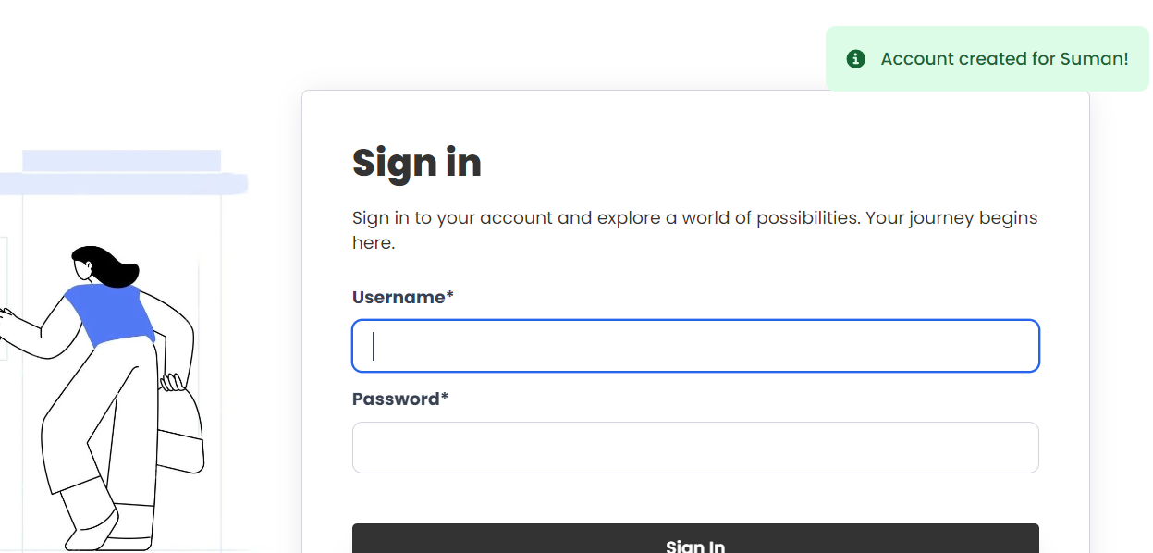

Figure 40 - System Testing (1) - Account is created

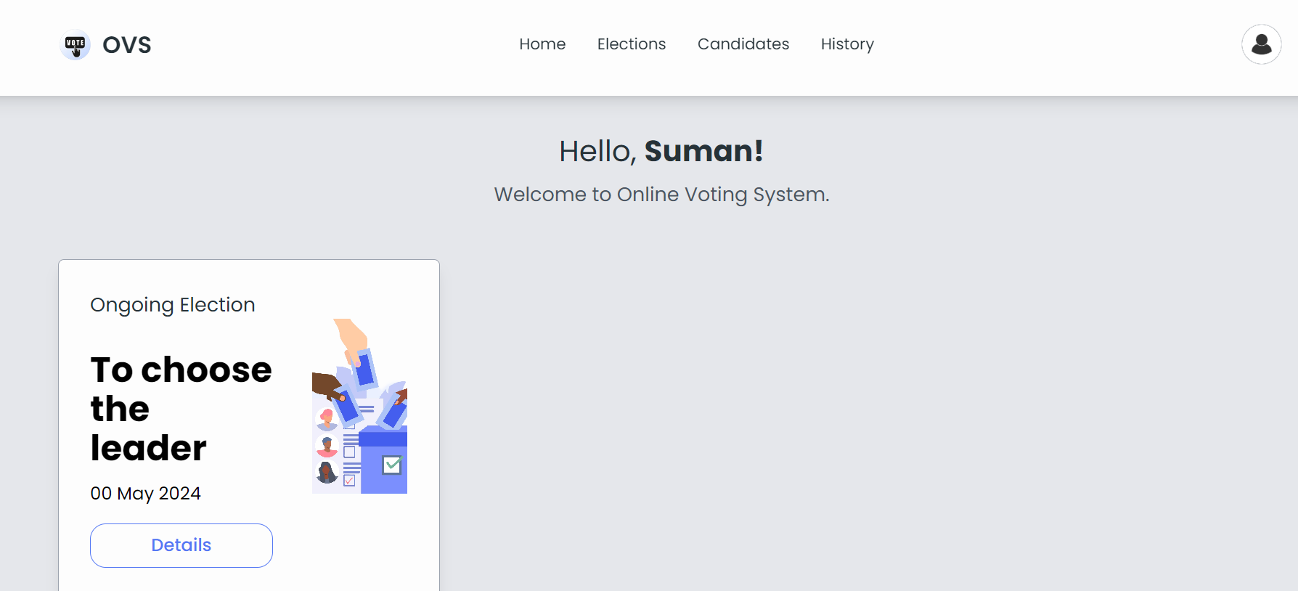

Figure 41 - System Testing (2) -Login is successful

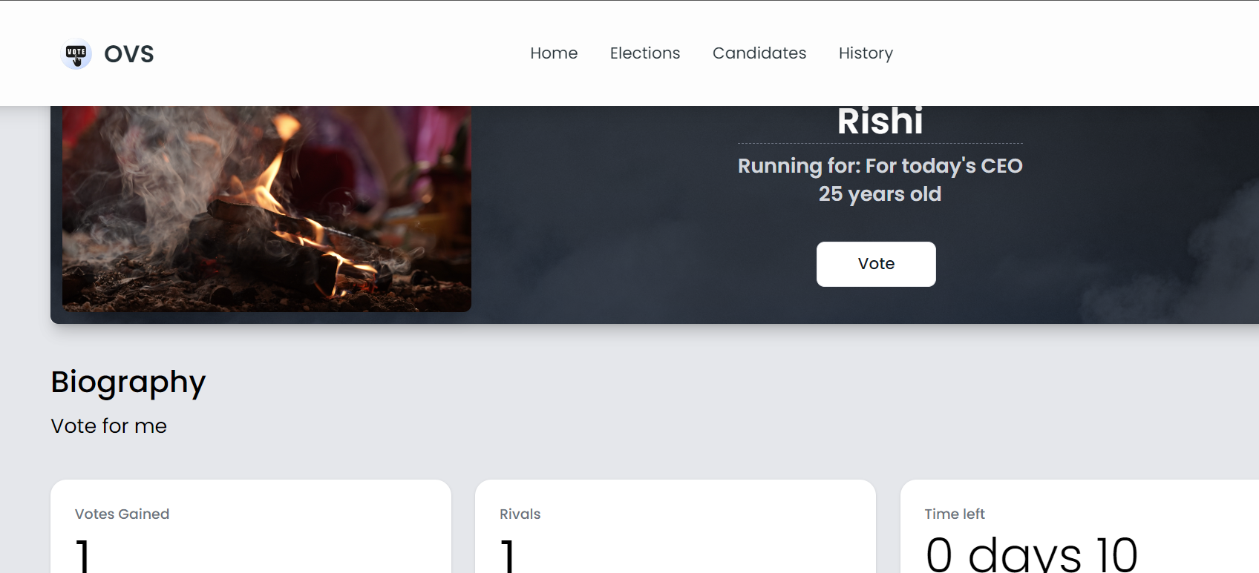  
Figure 42 - System Testing (3) -User can login

1. Admin can create and vote.

|  |  |  |
| --- | --- | --- |
| Test no | Expected outcome | Status |
|  | Election lifecycle can create, vote and results | Pass |

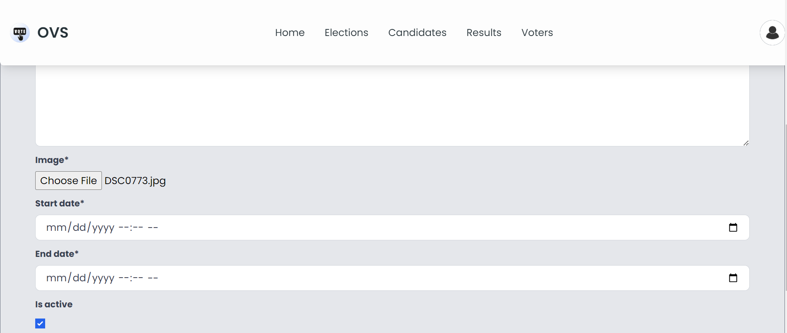

Figure 43 - System Testing (4) -Creating election



Figure 44 - System Testing (5) -Successfully created election  
Figure 45 - System Testing (6) - voting the candidate



Figure 46 - System Testing (7) -Successfully voted in the election



Figure 47 - System Testing (8) -Results can be displayed like this

1. Admin and User role

|  |  |  |
| --- | --- | --- |
| Test no | Expected outcome | Status |
|  | There should be control of admin | Pass |

Admin can add, edit and delete election. But cannot vote in the election through the admin.

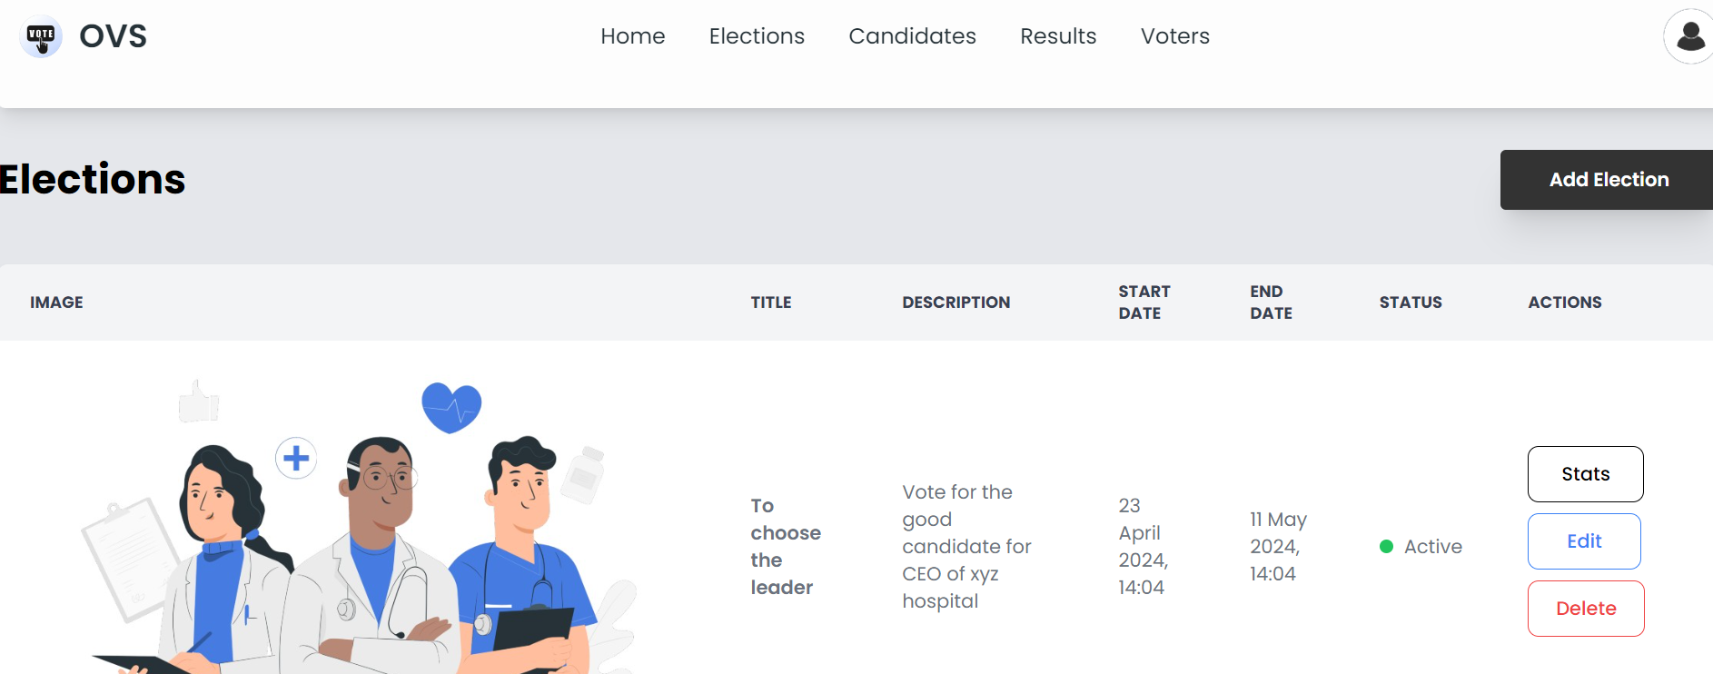

Figure 48 - System Testing (9) -Adding, editing and deleting election

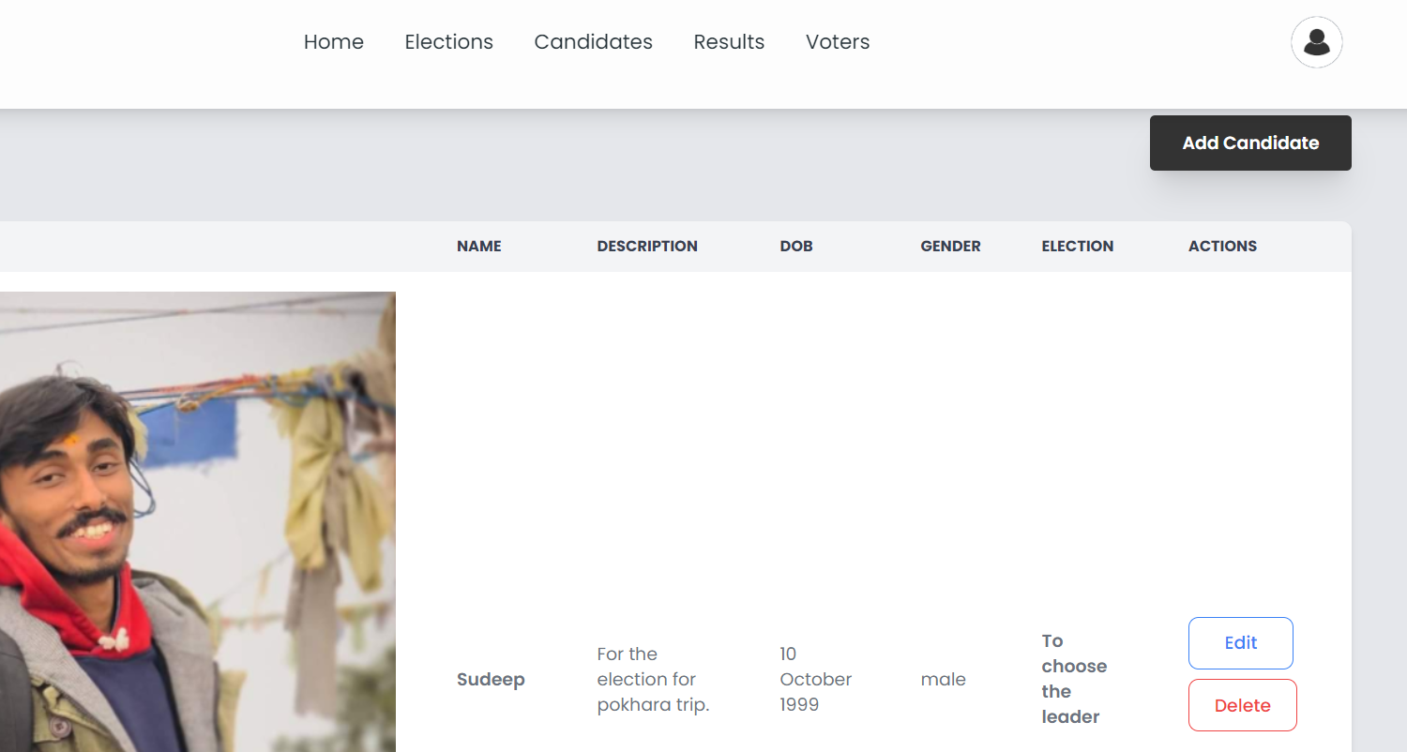

Figure 49 - System Testing (10) -Admin who have control about editing, deleting the canidates

Figure 50 - System Testing (11) -Admin can declare winner in the results

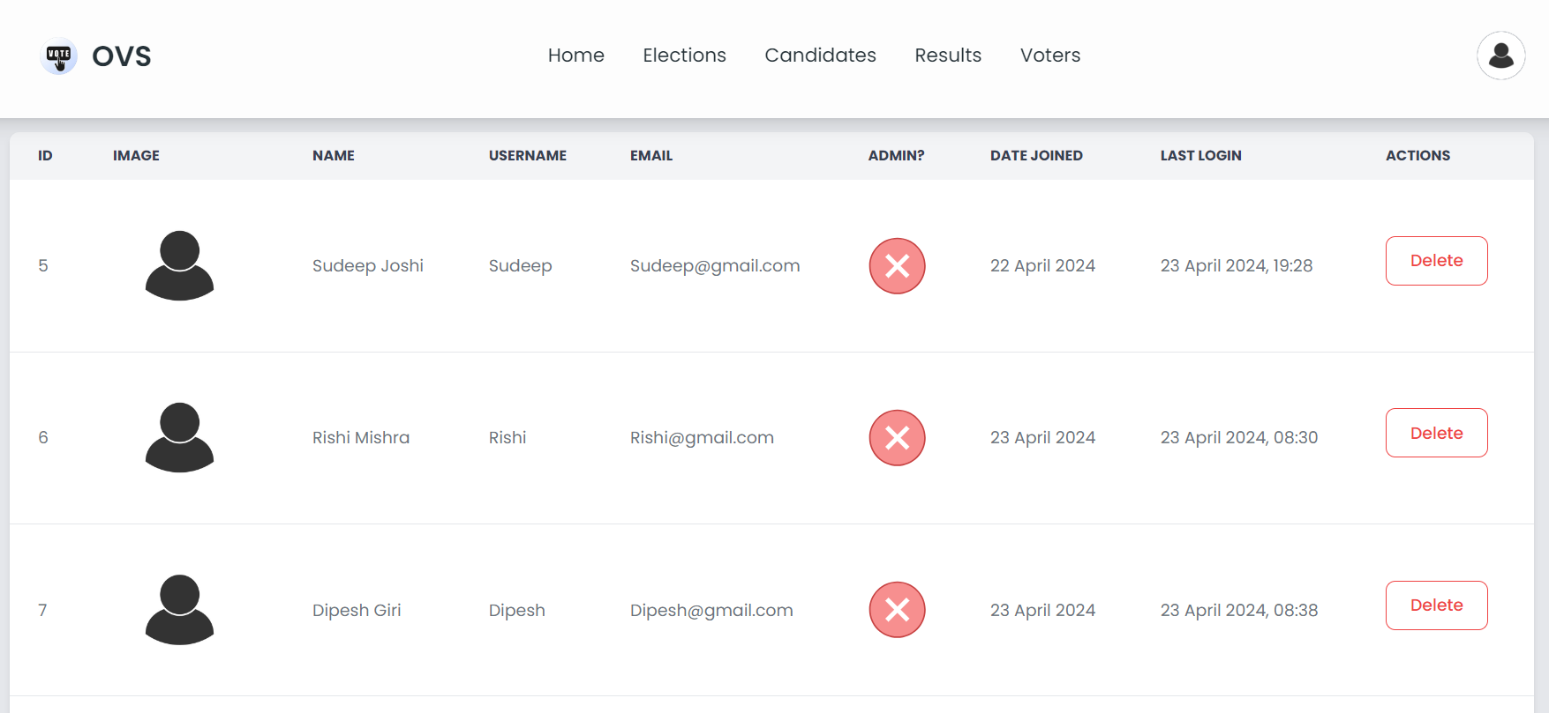  
Figure 51 - System Testing (12) - Admin can delete the voters.

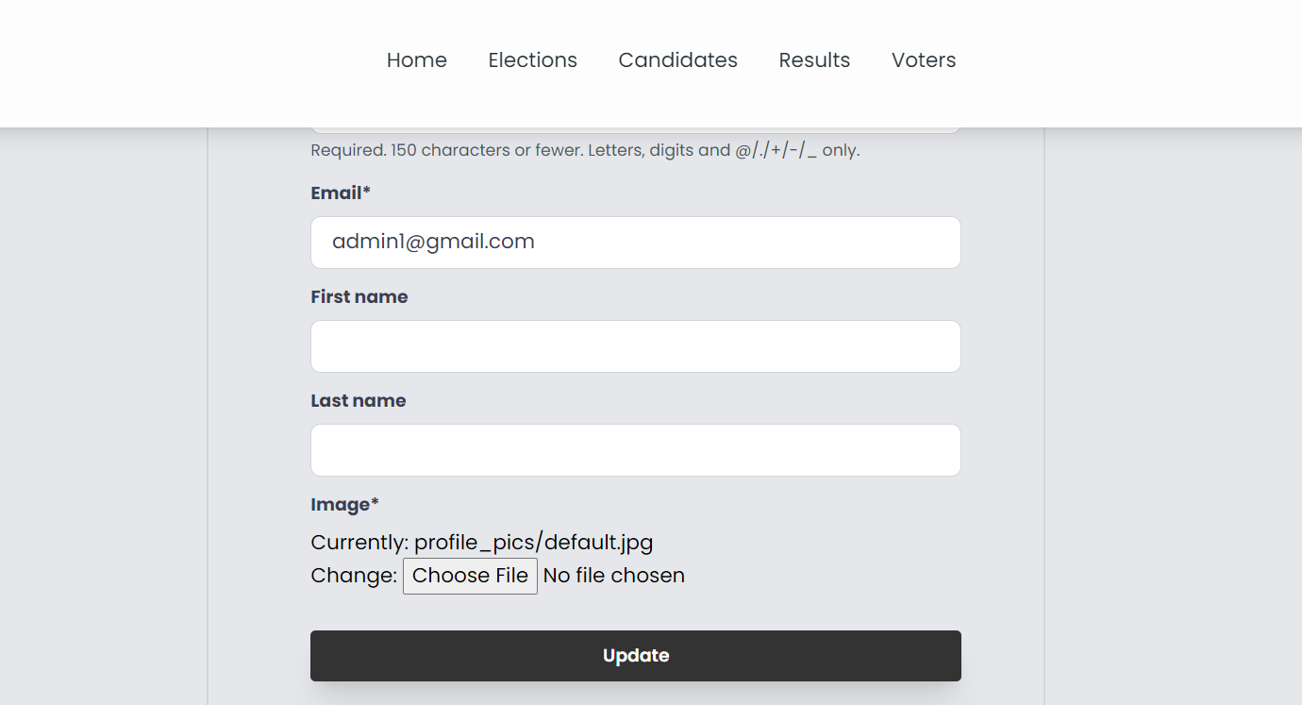

Figure 52 - System Testing (13) -Admin can edit their profile

1. Checking database integrity

|  |  |  |
| --- | --- | --- |
| Test no | Expected outcome | Status |
|  | There should be no error while checking database integrity | Pass |

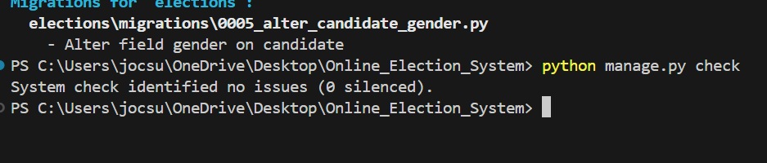

Figure 53 - System Testing (14) - Checking database integrity

* 1. **Critical Analysis**

The completion of all unit tests during the voting system development phase is vital because it guarantees that each critical feature, such as authentication, election creation, voting processes, user profile management, and access control, works as intended. Passing these tests confirms the system's ability to securely handle user authentication, create correct elections, record votes, properly manage user profiles, and apply suitable access control measures. This good conclusion illustrates the developers' adherence to standard procedures and coding standards, which instills confidence in the system's granular operations.

While unit testing gives useful insights to individual component behavior, it does not ensure flawless integration and interaction throughout the larger system context. As a result, it is critical to combine unit testing with full system testing, which assesses overall system behavior and ensures all components operate together to deliver the intended functionality. System testing includes user experiences, election process management, user roles and rights, accuracy of data, workload performance, and usability. Unit and system testing may uncover, assess, and address possible flaws or faults early in the development process. This method yields a strong, dependable, and effective voting system which successfully solves user needs and meets their expectations.

**Chapter 5: Conclusion**

1. **Conclusion**

In conclusion, unit tests throughout voting system design are critical since they demonstrate the system's capacity to satisfy functional criteria successfully. These tests guarantee that key functionality such as login, election creation, voting techniques, account management, along with access control work properly. Successfully completing these tests demonstrates developers' ability to create trustworthy operations, adhere to best habits, and maintain code quality. To guarantee smooth integration as well as interaction across every system component within the larger context, unit testing must be combined with system testing.

Unit testing is vital because it examines the performance of individual components, which serves as the foundation for system testing. System testing, which includes real-world situations, evaluates the overall performance of the system in areas such as user experience, election administration, roles and privileges, data integrity, load efficiency, and usability. Comprehensive system testing aids in the identification and correction of faults or inconsistencies, resulting in a strong, dependable, as well as high-quality voting system which fulfills the demands and expectations of its users. This procedure guarantees that the system works as a whole, resulting in highest efficiency and user satisfaction.

Thorough testing at both the unit as well as system levels through the development lifecycle is helpful in detecting any mistakes or problems early on, allowing for prompt correction. This proactive strategy not only reduces risks, but also guarantees that the final product satisfies user expectations, follows legal requirements, and is consistent with corporate standards. This improves the system's dependability, scalability, and maintainability. This sturdy foundation provides the way for future improvements, modifications, and adaptability to meet changing demands and technology breakthroughs.

Effective unit testing is critical in building trust among stakeholders, including as developers, project managers, and end users, in the system's dependability and preparedness for deployment. It is a significant achievement during the planning phase, demonstrating progress toward project objectives and benchmarks. It also encourages cooperation and engagement by fostering the exchange of ideas and perspectives, which leads to continual growth and creativity during the development process. To summarize, effective unit testing leads to a reliable, well-prepared system while also enhancing collaboration and encouraging creativity.

Overall, designing and evaluating the voting system is critical to advancing democratic values and increasing citizen engagement. The system promotes democracy, maintains integrity, and instills trust in the electoral process by utilizing technology to assure fair, transparent, and accessible elections. Finally, this allows people to utilize their basic right to vote, which influences the course of their society and civilizations.

Consistent review, maintenance, and iterative changes are critical for maintaining the voting the system's effectiveness, security, and relevancy in the long run. Fostering a culture of continuous improvement and innovation inside businesses is critical for assuring the system's capacity to adapt and prosper in the face of changing user needs, technology advancement, and regulatory changes. By consistently pursuing these initiatives, the voting system may improve its effectiveness and lifespan in an ever-changing world.

* 1. **Legal Issues, Social Issues, Ethical issues**

Several legal, social, and ethical considerations should be made while developing and implementing the voting system in which the project is completed using DSDM model.

* + 1. **Social Issues**

The voting system should promote social inclusion as well as accessibility by accommodating voters' different demands and talents, including those with disabilities or inadequate computer skill. This may be accomplished by providing user-friendly interfaces and supporting many languages. To build user trust and confidence, the system should give open and accurate information regarding the voting process, as well as assure that results are counted correctly and impartially. By addressing these issues, the system may foster an inclusive atmosphere and encourage active involvement by a diverse variety of people within the democratic process.

* + 1. **Legal Issues**

In legal terms, the voting system must follow all applicable laws and norms governing voting operations, data protection, privacy, and cybersecurity. This includes following election-specific regulations governing voter eligibility, vote authenticity, campaign money, and reporting requirements. Furthermore, the system must have strong security measures to protect against any cyber-attacks, data breaches, and efforts to influence election results, maintaining the overall integrity and trustworthiness of the process.

* + 1. **Ethical Issues**

Ethically, the voting system must be faithful to ideals of fairness, openness, and privacy. It is critical to provide equal voting rights to all competent individuals, without prejudice or bias. Furthermore, strong safeguards should be installed to protect the privacy and safety of voter information, prohibiting unwanted access or manipulation. By adhering to these ideals, the system may sustain its integrity while also fostering confidence among democratic users and stakeholders.

* 1. **Advantages**
* The system is user-friendly. So it can be used by anyone from any location with internet access
* The system has efficiency while registration, and other thing while conducting election.
* The system implements encryption, authentication and auditing cyber threats and protects against unauthorized access.
* This system is cost-effectiveness
* By providing online voting option, participation can be encouraged as well as encourage about other people too.
  1. **Future work**
* There should be improvement and updating in security measures to stay ahead of new threats and vulnerabilities.
* To enhance transparency, immutability and auditability of the voting process there should be integration of block chain technology.
* There should be involvement of the advancing advanced data analytics capabilities to analyze patterns, trends and demographics.
* Collaboration with stakeholder, including voters, election officials , government agencies and advocacy group should be maintained
  1. **Limitation**Despite of other thing, there are several limitations which includes
* Security risks
* Digital Divide
* Privacy concerns
* Trust and Transparency
* Legal as well as regulatory challenges
* Technical Complexity

## **Chapter 6: Reference and Biography**

# **References and bibliography**

*How did Estonia carry out the world’s first mostly online national elections - E-ESTONIA*. e. (2023, April 26). <https://e-estonia.com/how-did-estonia-carry-out-the-worlds-first-mostly-online-national-elections/>

Aarya Rijal| May 30. (2022, May 30). *Electronic elections in Nepal: Understanding the past,present and the future*. Nepal Economic Forum.<https://nepaleconomicforum.org/electronic-elections-in-nepal-understanding-the-past-present-and-the-future/>

Commission , A. E. (n.d.). Report into electronically assisted voting at the 2007 federal ... <https://www.aph.gov.au/Parliamentary_Business/Committees/House_of_Representatives_Committees?url=em/elect07/subs/sub169_1.pdf/>

Habibu, T., & Sharif, K. (2017). (PDF) design and implementation of electronic votingsystem.<https://www.researchgate.net/publication/319176839_Design_and_Implementation_of_Electronic_Voting_System/>

P, V., & V, N. (2022, March). Final year project – report ... <https://sist.sathyabama.ac.in/sist_naac/documents/1.3.4/1822-b.tech-it-batchno-340.pdf/>

What is Scrum? - scrum methodology explained - AWS. (n.d.). <https://aws.amazon.com/what-is/scrum/>

GeeksforGeeks. (2022, March 27). *Kanban - Agile methodology*. <https://www.geeksforgeeks.org/kanban-agile-methodology/>

Tutorial points. (n.d.). *SDLC - iterative model*. Tutorialspoint. <https://www.tutorialspoint.com/sdlc/sdlc_iterative_model.htm>

*Database design - learn how to design a good database*. Astera. (2023, October 20). <https://www.astera.com/type/blog/all-you-need-to-know-about-database-design/#:~:text=What%20is%20Database%20Design%3F,for%20the%20proposed%20database%20system>.

**Chapter 7: Appendix**

1. **Appendix**
   1. **Appendix A: Pres survey**













* 1. **Appendix B : Post survey**















* 1. **Appendix C : Sample Codes**

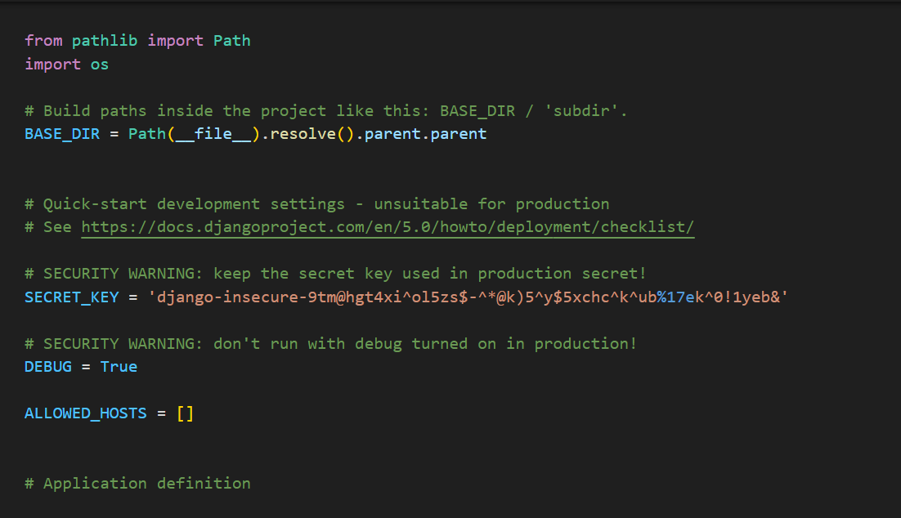

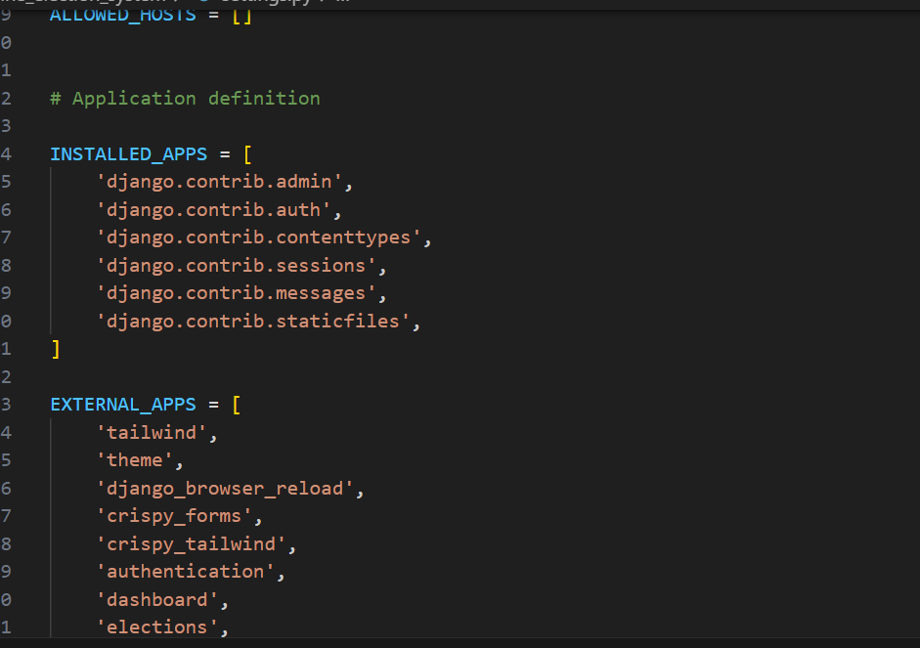

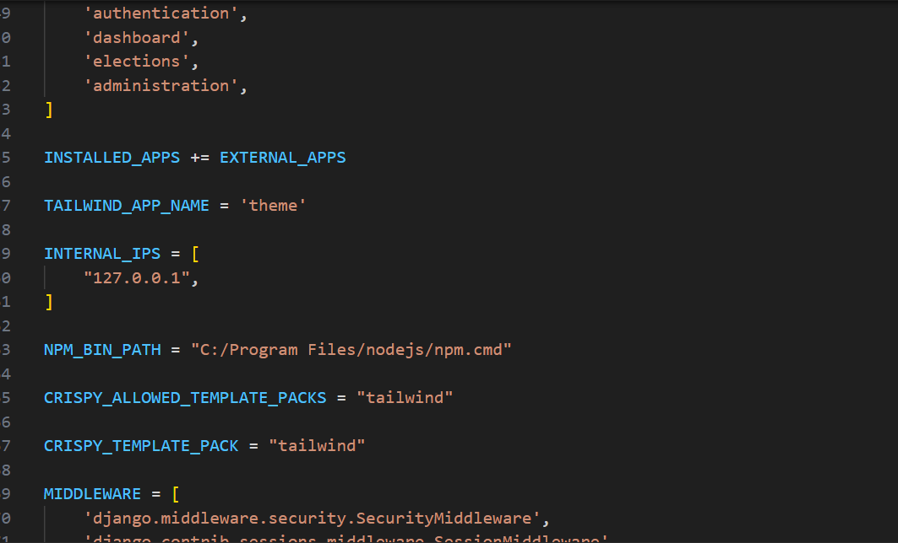

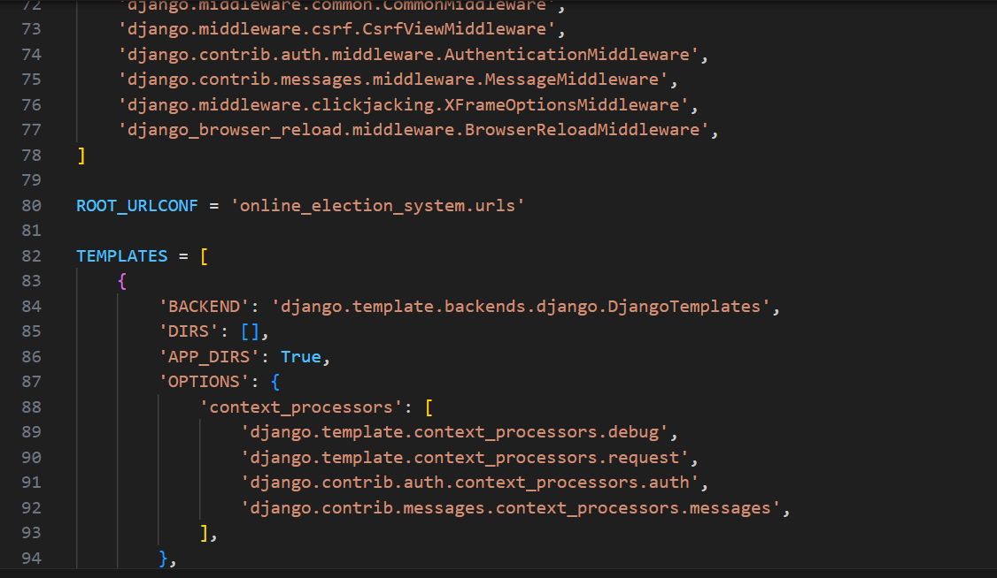

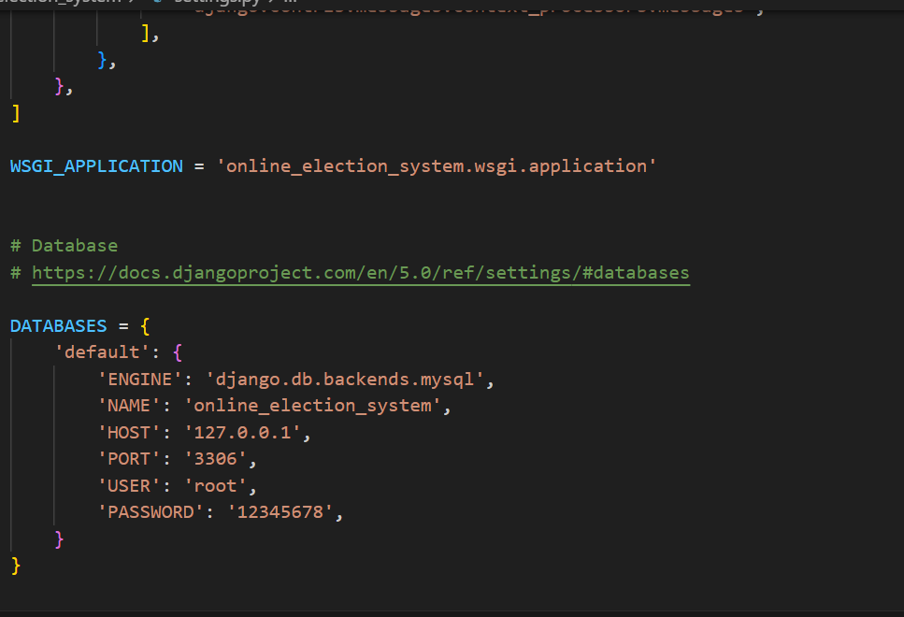

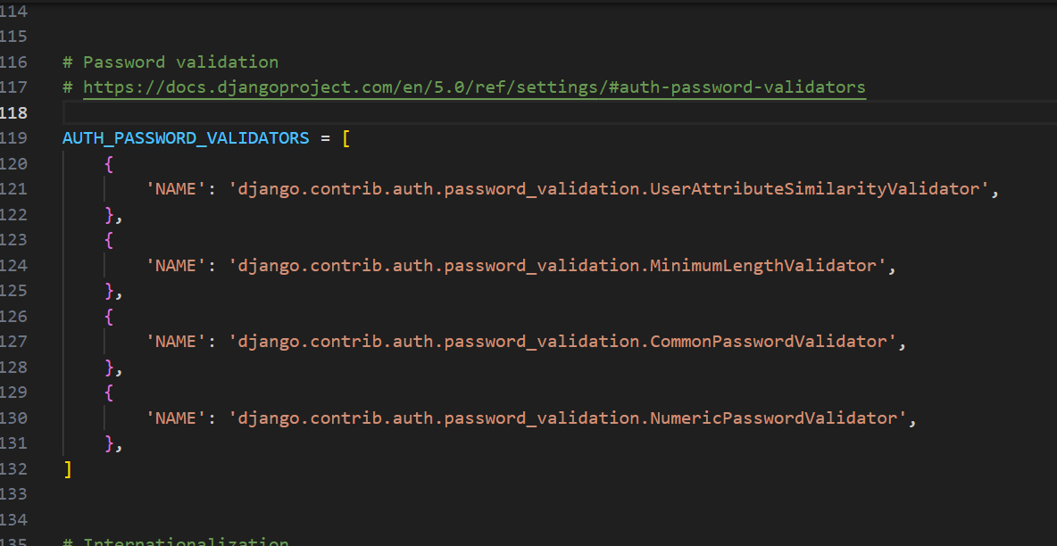

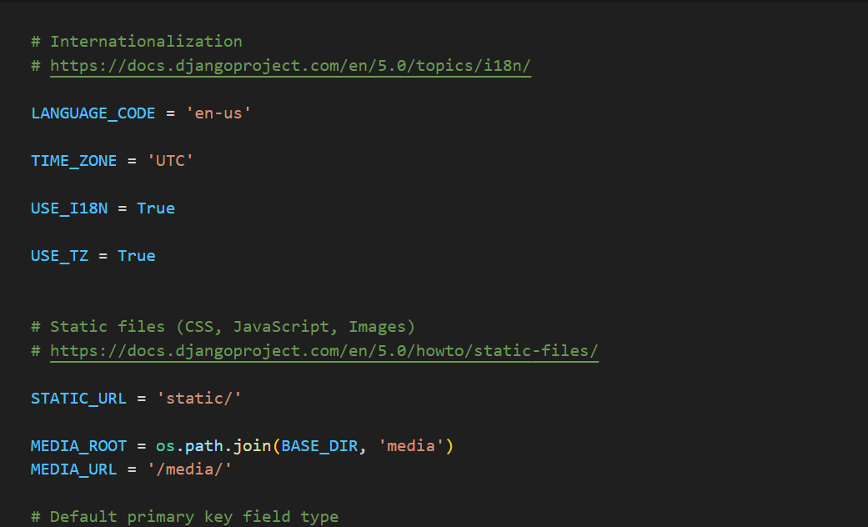

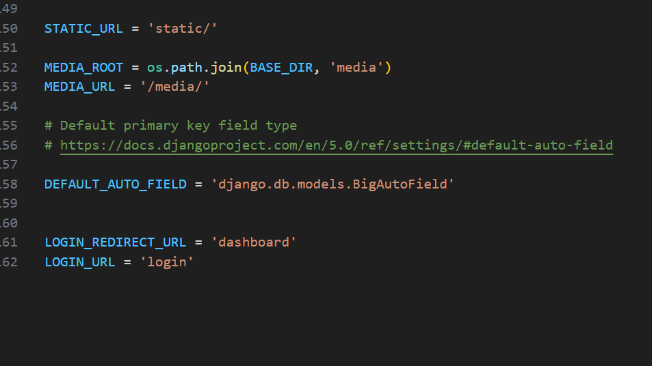

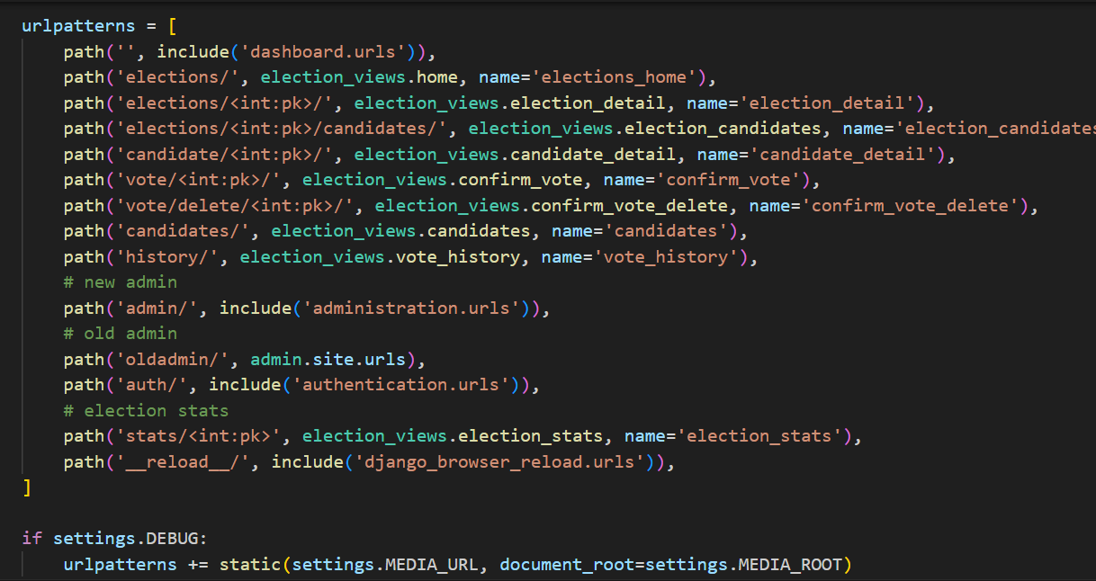

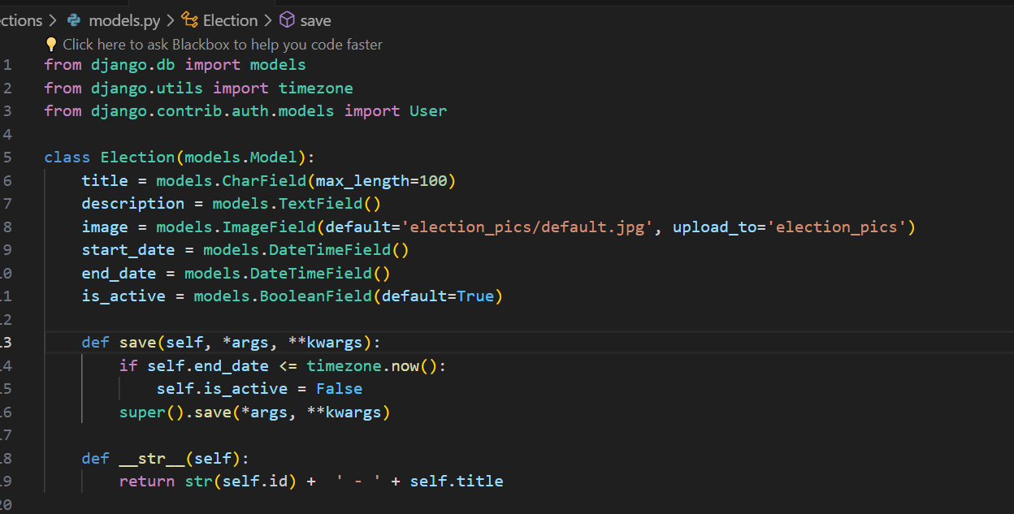

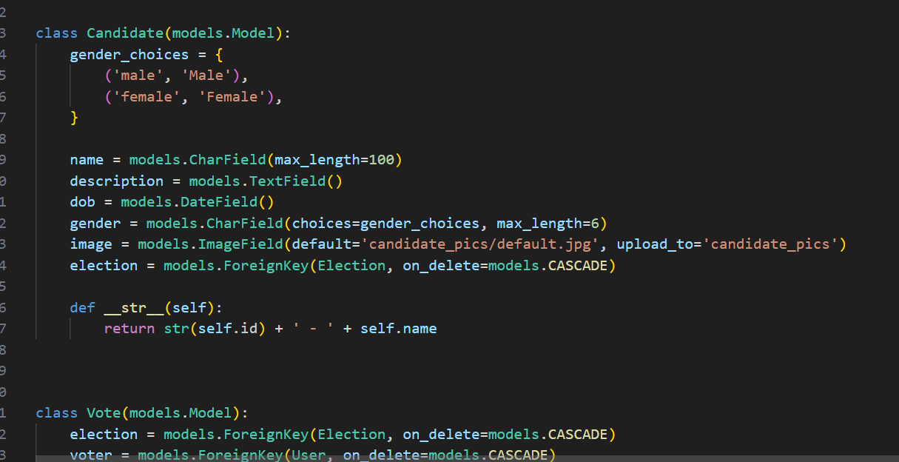

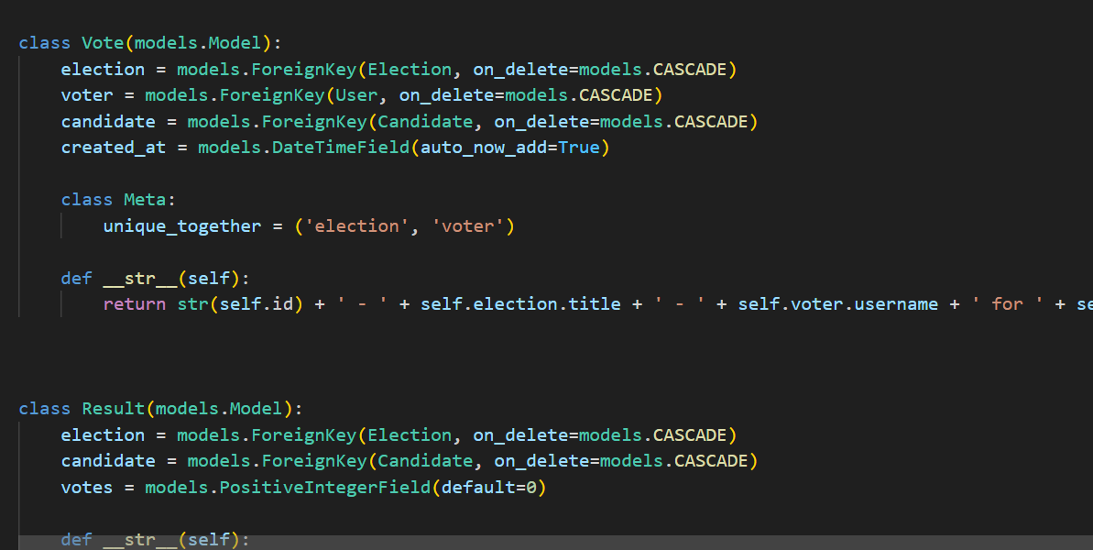

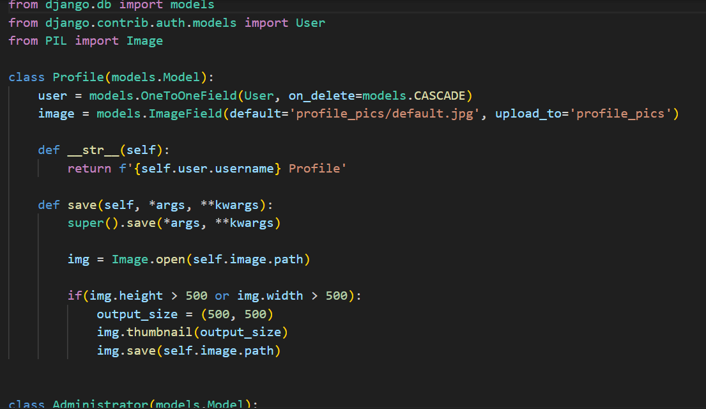

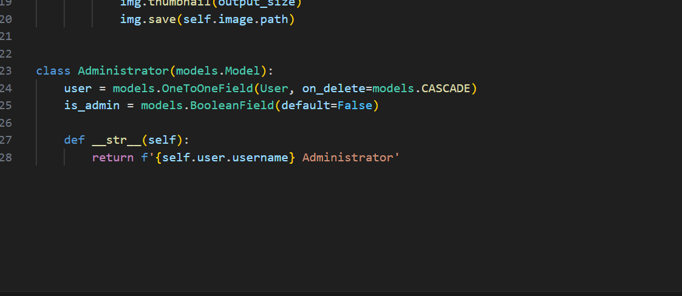

* 1. **Appendix D: Design**

**Gantt chart**

An illustration of the timeline of tasks and activities needed to finish a project is provided by a Gantt chart, a visual tool in project management. Activities are shown as horizontal bars that are displayed throughout time, with the task duration indicated by the length of each bar. Project managers may effectively manage the project timeline and highlight important route activities by using Gantt charts, which also display task dependencies. They are useful for scheduling, monitoring, and informing stakeholders of project status.

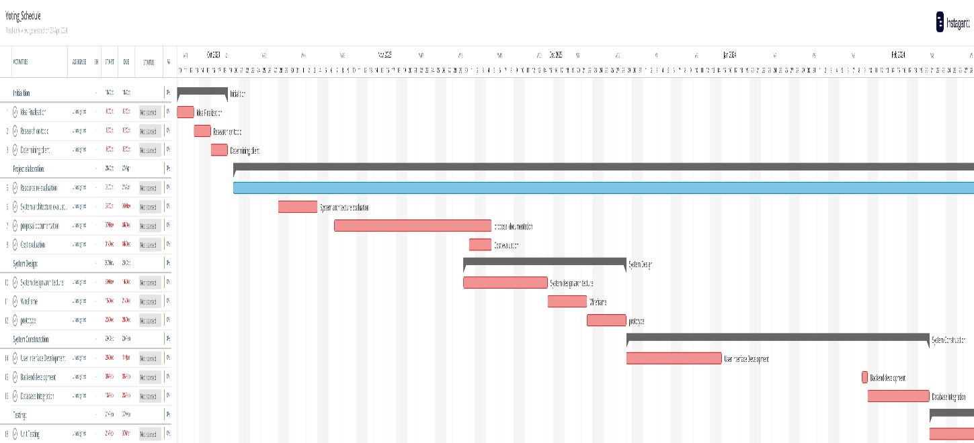

<https://app.instagantt.com/shared/6628286d41670d12d33c1ece>

**Use Case Diagram**

An illustration of how people interact with a system or software program is called a use case diagram. It displays the different methods in which users can engage with the system as well as the features that it offers to meet users' demands and accomplish particular objectives.

Actors in a use case diagram stand in for various user categories or external systems interacting with the system under model. Use case diagrams are useful for documenting system requirements, delineating system boundaries, and comprehending a system's general functionality from the viewpoint of a user. They are frequently used in software development to support stakeholder communication, requirements analysis, and design validation.

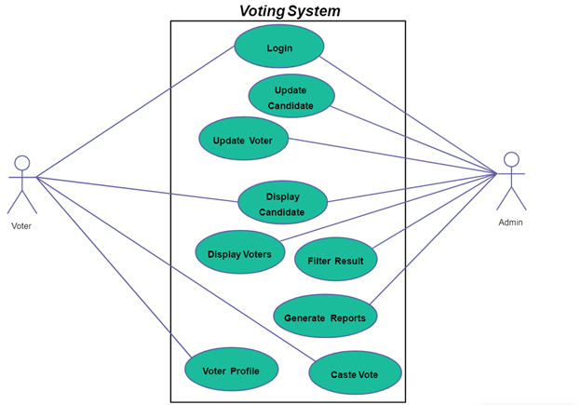

**Algorithm**

An algorithm is a collection of instruction to solve a problem or completing a job. A recipe is a frequent example of an algorithm, as it contains explicit instructions for producing a dish or meal. Every computerized device performs its operations using algorithms, which might be hardware or software-based procedures.

In finance, algorithms are now used to construct automated and high-frequency trading (HFT) systems, as well as to price complicated financial products such as derivatives.

**Flow Chart**

A flowchart depicts the successive phases of a process. It is a general tool that may be used to define a wide range of processes, including manufacturing, administration, and service, as well as project planning. They are very useful resources for communicating between various stakeholders or inside teams, as well as for analysis, optimization, and documentation. They can also help identify mistakes, cuts, or delays in a procedure so that improvements can be implemented.



**Dataflow Diagram**

A data flow diagram (DFD) is a diagram which helps in showing how data moves through a system or process. It shows how the data travels through procedures from external sources to various places within the system. In software engineering and systems analysis, DFDs are frequently used to model the system and comprehend the behavior along with the structure of systems. Systems analysts and designers find DFDs to be useful tools because they can facilitate the visualization of data flow, the identification of possible problems or delays, and the clear and organized the communication of complex systems.



**System Activity diagram**

An action or activity sequence carried out within a system over time is depicted in the system activity diagram. It displays the flow of control between different operations as well as how they are started, carried out, and finished. These diagrams, which do not concentrate on particular parts or implementation details, aid in the visualization of a system's dynamic behavior, including interactions between the users, processes, along with the external entities.



**Class Diagram**

A class diagram is an example of a UML (Unified Modeling Language) diagram, which depicts the classes of objects, their attributes, methods, and interactions between them to demonstrate a system's structure. It provides a more abstract, visual depiction of a system's static structure. Class diagrams are commonly used in software development that is object-oriented to build and depict software systems' organizational structures. They facilitate the formation of class structures, the determination of reusable portions, sharing of system structure between stakeholders, and the comprehension of the relationships between multiple classes.



**Graphical User Interface**

A graphical user interface (GUI) is a type of user interface that uses visual cues, graphical components such as the windows buttons, menus, and dialog boxes, as well as graphical icons, to help users interact with electronic devices or software applications. In comparison with text-based interfaces, it provides users with a more visually appealing as well as straightforward way to engage with a system. Within a GUI:

1. Visual Elements: Windows, icons, buttons, checkboxes, radio buttons, sliders, and text fields are just a few of the visual elements that make up a graphical user interface. These components stand for various user-accessible features or options.

2. Point-and-Click Interaction: To select and work with graphical components on the screen, users interact with the GUI by using a pointing device, such as a mouse, touchpad, or touchscreen. Oftentimes, this type of interaction is called "point-and-click" or "drag-and-drop."

3. Menus and Toolbars: Additional features, commands, and settings are usually accessible through the menus and toolbars that are a standard feature of GUIs. Menus are arranged in hierarchical lists of options or commands, whereas toolbars have icons that correspond to frequently used commands.

4. Feedback and Visual Feedback: Graphical user interfaces (GUIs) give consumers visual feedback about how the system is reacting to their activities. Changes to the look of graphical elements, animations, progress bars, or notifications are examples of this input.

5. Window management: Because GUIs offer the idea of numerous windows, users can work on multiple documents or applications at once. To fit their tastes, users can rearrange, maximize, reduce, and rearrange the windows on the screen.

In general, graphical user interfaces (GUIs) improve the user experience by providing an interactive and visually stimulating environment that makes interacting with software and electronic devices easier. Operating systems, desktop software, mobile apps, and web interfaces all make extensive use of them.

**Wire Frames**

Wireframes, often known as graphic representations or blueprints, illustrate the core structure and layout of a web page, mobile app screen, or user interface. Without focusing on particular design components like as colors, images, or typeface, they are created in the early stages of the creative process to represent and explain the arrangement of things on a digital interface. Wireframes are an important tool in the design process among designers and stakeholders since they help to visualize and develop the design and arrangement of digital interfaces. Before dedicating time and money to elaborate visual design and creation, they stimulate cooperation, accelerate decision-making, and ensure consensus on essential design components..

**Application Design**

Application design refers to the process of creating, organizing, and developing the structure, organization, functionality, and user interface of a software application. It comprises a series of activities aimed at defining the application's objectives and specifications, designing its interface, design, and characteristics, and then developing and testing the program to ensure that it meets the demands of the users. Good application design requires collaboration among designers, developers, stakeholders, and users in order for a software application to be effective and user-centric while also meeting the needs of its target audience. Over the entire design and development process, thorough planning, ingenuity, great attention to detail, and consistent progress are required.











* 1. Appendix E: SCREENSHOTS OF THE SYSTEM











* 1. **SRS documents**

**Introduction**

**Project Scope**

Nepal lags behind in terms of appropriate education and economic development. Infrastructure such as power, internet, and other services are not widely available throughout the country. Despite the fact that the initiative has the potential to be successful in the available portions of Nepal.

**Overall Description**

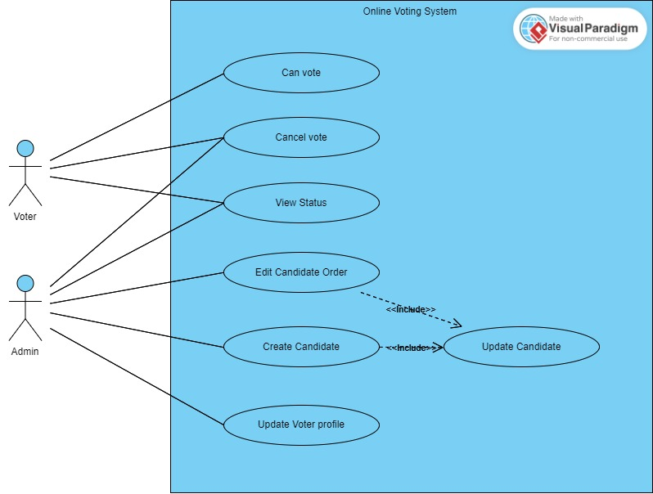

**System Features**

* Vote in the election
* Get the status of the report
* Friendly UI design
* Admin Controller

User class and characteristics

UC1: User

Uc1.1

Can register as voter

UC1.2

Can watch all the status of the ongoing election

UC1.3

Can cast the vote

UC1.4

Can update the given vote

UC2: Admin

UC2.1

Can perform CRUP operation from Admin panel

UC2.2

Can add delete elections.

**Operating Environment**

In the present context, this application is based on web applications so all the web application applicable devices can enter the voting system.

**Design and Implementation**

The user cannot alter the data from database

**Assumptions and Dependencies**

Functional Requirements

|  |  |  |  |
| --- | --- | --- | --- |
| Reg. ID | Requirements Description | Priority | Complexity |
| 1 | All the users will be able to register themselves   |  | | --- | | System requirements | | |  |  | | --- | --- | | 1 | The application gets taken to the login page. | | 2 | Unregistered users can register them self by going via the register. | | | High | Medium |
| 2 | |  | | --- | | Registered users can access their own accounts, but not others.  System requirements | | |  |  | | --- | --- | | 1 | The application's user will be taken to the user page. | | 2 | If a person has registered, they may log in using their username and password. | | | High | medium |
| 3 | Login information will be saved in the database in an encrypted way. | high | low |